PK-Sim® Ontogeny Database

Table of contents
1 Aim 5
2 Data management 5
2.1 Literature data 5
2.2 Fit results 5
3 Methods 5
4 Results 6
4.3 CYP Enzymes in the liver 6
A.1 CYP1A2 in liver 6
A.1.1 Original data 6
A.1.2 Fit results 8
A.2 CYP2C18 in liver 10
A.2.1 Original data 10
A.2.2 Fit results 10
A.3 CYP2C19 in liver 12
A.3.1 Original data 12
A.3.2 Fit results 13
A.4 CYP2C8 in liver 15
A.4.1 Original data 15
A.4.2 Fit results 15
A.5 CYP2C9 in liver 17
A.5.1 Original data 17
A.5.2 Fit results 18
A.6 CYP2D6 in liver 20
A.6.1 Original data 20
A.6.2 Fit results 20
A.7 CYP2E1 in liver 22
A.7.1 Original data 22
A.7.2 Fit results 22
A.8 CYP3A4 in liver 24
A.8.1 Original data 24
A.8.2 Fit results 25
A.9 CYP3A5 in liver 27
A.9.1 Original data 27
A.9.2 Fit results 27
CYP3A7 in liver 29
A.9.3 Original data 29
A.9.4 Fit results 29
4.4 UGT enzymes in liver 31
A.1 UGT1A1 in liver 31
A.1.1 Original data 31
A.1.2 Fit results 32
A.2 UGT1A4 in liver 34
A.2.1 Original data 34
A.2.2 Fit results 34
A.3 UGT1A6 in liver 36
A.3.1 Original data 36
A.3.2 Fit results 36
A.4 UGT1A9 in liver 38
A.4.1 Original data 38
A.4.2 Fit results 38
A.5 UGT2B4 in liver 40
A.5.1 Original data 40
A.5.2 Fit results 40
A.6 UGT2B7 in liver 42
A.6.1 Original data 42
A.6.2 Fit results 43
4.5 CYP Enzymes in the intestine 45
A.1 CYP3A4 in duodenum 45
A.1.1 Original data 45
A.1.2 Fit results 45
4.6 Other enzymes 47
A.1 Carboxylesterase 1 (CES1) 47
A.1.1 Original data 47
A.1.2 Ontogeny results 47
4.7 Transporter 53
A.1 P-glycoprotein 1 (P-gp) 53
A.1.1 Original data 53
A.1.2 Ontogeny results 53
4.8 Plasma Proteins 55
A.1 Human Serum albumin (HSA) 55
A.1.1 Original data 55
A.1.2 Fit results 55
A.2 Alpha-1-acid glycoprotein (AAG) 57

Aim
This document represents a summary of literature data to ontogeny of enzymes, and other ADME relevant proteins as well as fit results used for implementation of ontogeny functions in PK-Sim®.

Data management

Literature data
Used literature data are referenced in the respective enzyme sections.

Fit results
Fit results and figures are illustrated in the respective enzyme sections.

Methods
A maturation model based on a sigmoidal Emax model (corresponding to the Hill-equation), published by Tod et al. 2008 (Clin Pharmacokinet. 47(4):231-43) presents the best description of age dependent development of e.g. proteins (Fig. 1). This model was also presented at the EMEA Workshop on Modelling in Paediatric Medicines in 2008 (Presentation ‘Prof. N. Holford, 2008, ‘Mechanism-Based Concepts of Size and Maturity’, www.ema.europa.eu/docs/en_GB/document_library/Agenda/2009/11/WC500010017.pdf).
Figure 1. Slide taken from ‘http://www.ema.europa.eu/docs/en_GB/document_library/Presentation/2009/11/WC500009792.pdf’)
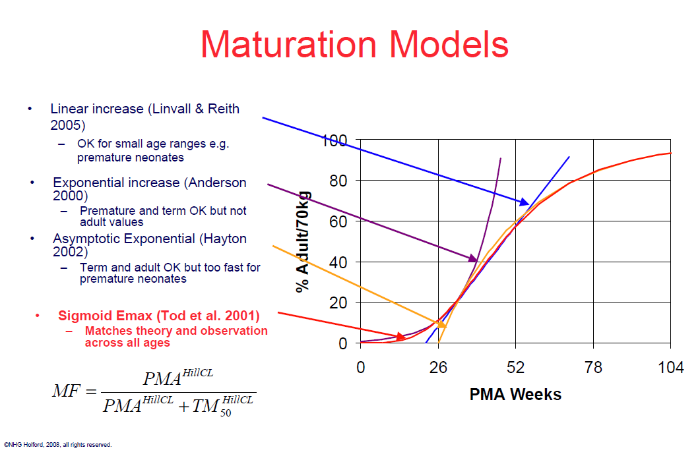

Fitting of ontogeny data was therefore performed using the following Hill equation (Equation 1):

A = PMA^{n}/( PMA^{n} + A_{0.5}^{n}) (1)

With:
PMA = Post-menstrual age in weeks
A = Relative activity at PMA
A_{0.5} = PMA (in weeks) at 50 % activity compared to adult
n = Hill coefficient

In the case of proteins showing decreased expression with increasing age, the following inverse fit function was applied (Equation 2):

A =1-PMA^{n}/(A_{0.5} ^{n} + PMA^{n}) + offset (2)

With offset = activity in adults

For fitting the ontogeny including variability, constituting variability in ontogeny as well as activity, a virtual population with 10000 individuals was created. Fitted were then the geometric mean and geometric standard deviation of the Hill coefficient (GeoSD n), the geometric mean and geometric standard deviation of PMA at 50% activity compared to adult (GeoSD A_{0.5}), and a geometric standard deviation as an activity variability factor (GeoSD adult).

All illustrated figures are shown in full age-length and a zoom-in version in the first period after birth. The presented tables are the implemented tables in PK-Sim, which are created from the fitted Hill equations.

For the ontogenies of CES1 and P-gp, no fitting was performed but ontogeny functions from the literature were selected and modified as described in the respective sections.

Results

CYP Enzymes in the liver

CYP1A2 in liver

Original data
Reference | Used for fit
Br J Clin Pharmacol. 1994 May;37(5):405-12.; Biotransformation of caffeine in human liver microsomes from foetuses, neonates, infants and adults.;Cazeneuve C, Pons G, Rey E, Treluyer JM, Cresteil T, Thiroux G, D'Athis P, Olive G.  Digital Object Identifyer (DOI): 10.1111/j.1365-2125.1994.tb05706.x  → Table 2 (Caffeine N-3 demethylation, and Caffeine N-7 demethylation) | Yes
Eur J Biochem. 1998 Feb 1;251(3):893-8.; Delayed ontogenesis of CYP1A2 in the human liver.; Sonnier M, Cresteil T.  Digital Object Identifyer (DOI): 10.1046/j.1432-1327.1998.2510893.x  → Figure 2a  → Figure 2b  → Figure 3 | Yes  Yes  Yes
Hepatology. 1991 Jun;13(6):1142-51.; Intralobular distribution and quantitation of cytochrome P-450 enzymes in human liver as a function of age.; Ratanasavanh D1, Beaune P, Morel F, Flinois JP, Guengerich FP, Guillouzo A.  Digital Object Identifyer (DOI): 10.1002/hep.1840130622  →Table 2 (protein content) | Yes

Fit results

Figure

Full range-plot Zoom-in, x-axis

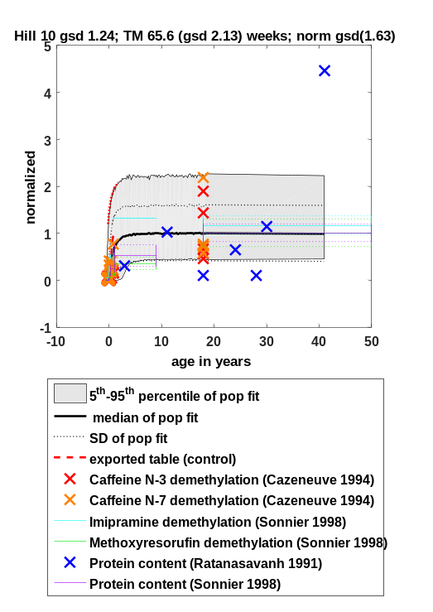 | 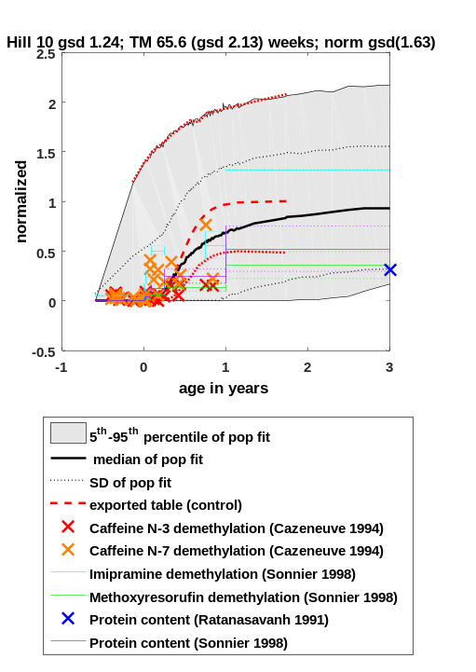

Fit function
Fit Result:
n = 10.015
A_{0.5} = 65.639

GeoSD n = 1.241
GeoSD A_{0.5} = 2.130
GeoSD adult = 1.628

A = PMA^{n}/(A_{0.5} ^{n} + PMA^{n})

With:
PMA = Post-menstrual age in weeks
A = Activity at PMA
A_{0.5} = PMA at 50 % activity compared to adult
n = Hill coefficient
GeoSD = geometric standard deviation
GeoSD adult = geometric standard deviation in activity observed in adults

Description for PK-Sim®
Values for CYP1A2 ontogeny are based on information to age dependency of Caffeine N-3 demethylation, Caffeine N-7 demethylation, Methoxyresorufin demethylation, Imipramine demethylation, and protein content, derived from the papers as mentioned in table A.1.1.

PK-Sim® Table

Post menstrual age [year(s)] | Ontogeny for CYP1A2 | Standard Deviation
0.629999995 | 0.00099 | 74.55000305
0.769999981 | 0.007 | 24.93000031
0.879999995 | 0.026000001 | 11.80000019
0.980000019 | 0.071000002 | 6.539999962
1.049999952 | 0.140000001 | 4.420000076
1.139999986 | 0.25999999 | 3.150000095
1.340000033 | 0.649999976 | 1.870000005
1.440000057 | 0.790000021 | 1.639999986
1.549999952 | 0.879999995 | 1.590000033
1.610000014 | 0.920000017 | 1.549999952
1.74000001 | 0.959999979 | 1.529999971
1.929999948 | 0.99000001 | 1.519999981
2.519999981 | 1 | 1.559999943

CYP2C18 in liver

Original data
Reference | Used for fit
Pharmacogenetics. 1997 Dec;7(6):441-52.; Developmental expression of CYP2C and CYP2C-dependent activities in the human liver: in-vivo/in-vitro correlation and inducibility.; Treluyer JM, Gueret G, Cheron G, Sonnier M, Cresteil T.  Pubmed ID (PMID): 9429229 (DOI not available)  → Figure 5 (mRNA expression) | Yes
Pharmacogenetics. 2003 Sep;13(9):565-75.; Differential expression and function of CYP2C isoforms in human intestine and liver.; Läpple F, von Richter O, Fromm MF, Richter T, Thon KP, Wisser H, Griese EU, Eichelbaum M, Kivistö KT.  Digital Object Identifyer (DOI): 10.1097/01.fpc.0000054122.14659.1e  Pubmed ID (PMID): 12972955 (DOI not functioning)  →Table 3 (mRNA expression) | Yes

Fit results

Figure

Full range-plot Zoom-in, x-axis
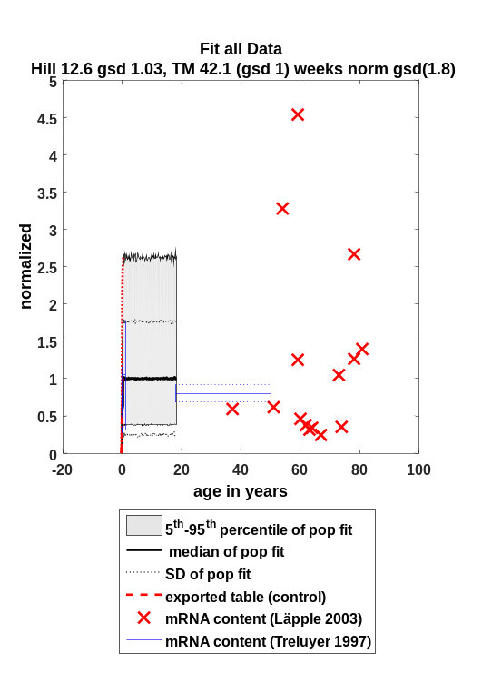 | 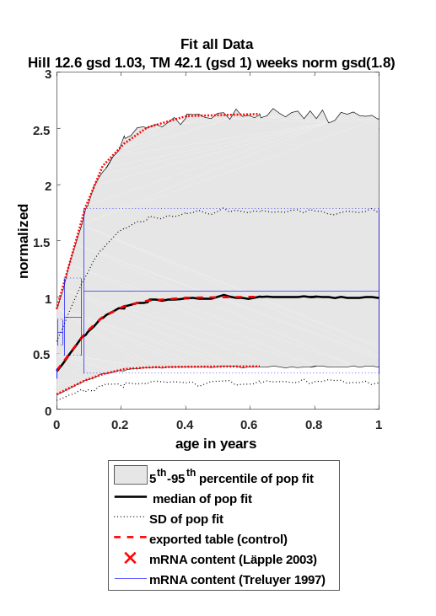
Comment: For the intestine, the geometric standard deviation in activity observed in adults (‘GeoSD adult’) has been separately fitted and implemented with a GeoSD of 2.177.

Fit function
Fit Result:
n = 12.590
A_{0.5} = 42.134

GeoSD n = 1.034
GeoSD A_{0.5} = 1.002
GeoSD adult = 1.795

A = PMA^{n}/(A_{0.5} ^{n} + PMA^{n})

With:
PMA = Post-menstrual age in weeks
A = Activity at PMA
A_{0.5} = PMA at 50 % activity compared to adult
n = Hill coefficient
GeoSD = geometric standard deviation
GeoSD adult = geometric standard deviation in activity observed in adults

Description for PK-Sim®
Values for CYP2C18 ontogeny are based on information to age dependency of mRNA expression, derived from the papers as mentioned in table A.2.1.

PK-Sim® Table

Post menstrual age [year(s)] | Ontogeny for CYP2C18 | Standard Deviation
0.469999999 | 0.00098 | 1.870000005
0.600000024 | 0.022 | 1.809999943
0.680000007 | 0.090999998 | 1.789999962
0.730000019 | 0.200000003 | 1.799999952
0.769999981 | 0.340000004 | 1.789999962
0.860000014 | 0.680000007 | 1.809999943
0.910000026 | 0.819999993 | 1.799999952
0.980000019 | 0.920000017 | 1.779999971
1.049999952 | 0.959999979 | 1.789999962
1.169999957 | 0.99000001 | 1.799999952
1.399999976 | 1 | 1.799999952

CYP2C19 in liver

Original data
Reference | Used for fit
J Pharmacol Exp Ther. 2004 Mar;308(3):965-74. Epub 2003 Nov 21.; Developmental expression of human hepatic CYP2C9 and CYP2C19.; Koukouritaki SB, Manro JR, Marsh SA, Stevens JC, Rettie AE, McCarver DG, Hines RN.  Digital Object Identifyer (DOI): 10.1124/jpet.103.060137  → Figure 3 (protein content)  → Table 2 ((S)-Mephenytoin 4-hydroxylation) | Yes  Yes
Pharmacogenetics. 2003 Sep;13(9):565-75.; Differential expression and function of CYP2C isoforms in human intestine and liver.; Läpple F, von Richter O, Fromm MF, Richter T, Thon KP, Wisser H, Griese EU, Eichelbaum M, Kivistö KT.  Digital Object Identifyer (DOI): 10.1097/01.fpc.0000054122.14659.1e  Pubmed ID (PMID): 12972955 (DOI not functioning)  → Table 3 (mRNA expression)  → Table 6 (protein content) | Yes  Yes

Fit results

Figure

Full range-plot  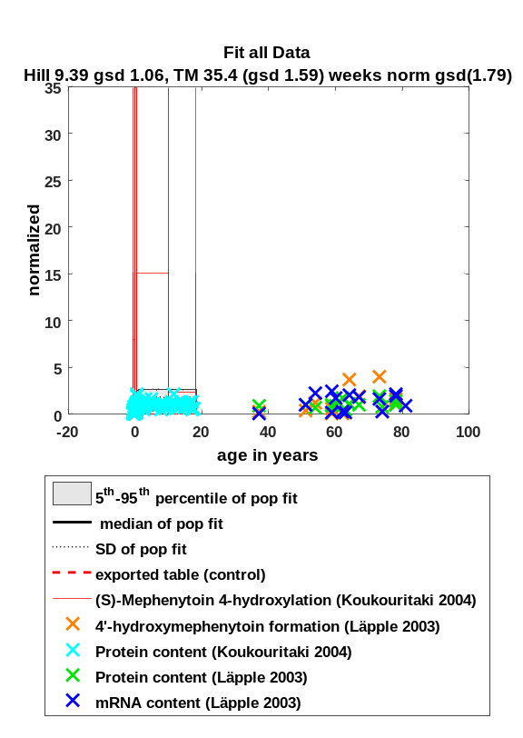  Zoom-in, y-axis  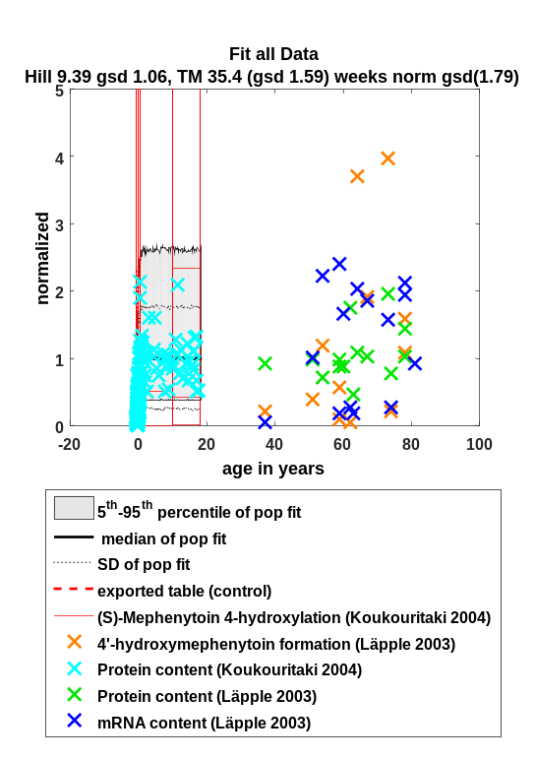 | Zoom-in, x-axis  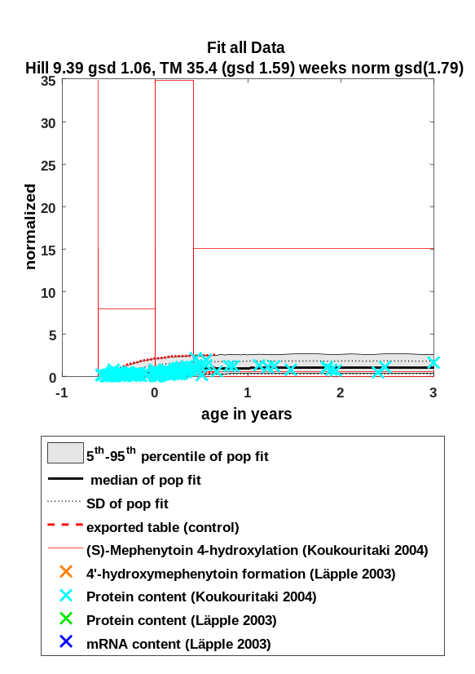  Zoom-in, x-axis and y-axis  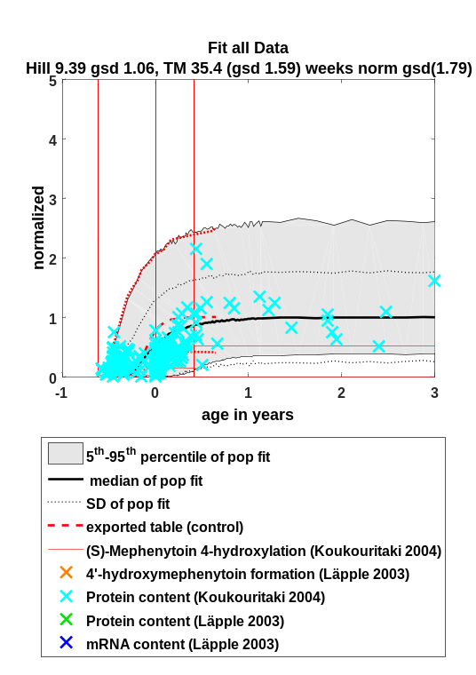
Comment:
For the intestine, the geometric standard deviation in activity observed in adults (‘GeoSD adult’) has been separately fitted and implemented with a GeoSD of 2.883.

Fit function
Fit Result:
n = 9.390
A_{0.5} = 35.447

GeoSD n = 1.055
GeoSD A_{0.5} = 1.592
GeoSD adult = 1.793

A = PMA^{n}/(A_{0.5} ^{n} + PMA^{n})

With:
PMA = Post-menstrual age in weeks
A = Activity at PMA
A_{0.5} = PMA at 50 % activity compared to adult
n = Hill coefficient
GeoSD = geometric standard deviation
GeoSD adult = geometric standard deviation in activity observed in adults

Description for PK-Sim®
Values for CYP2C1* ontogeny are based on information to age dependency of mRNA expression, protein content and (S)-Mephenytoin 4-hydroxylation derived from the papers as mentioned in table A.3.1.

PK-Sim® Table

Post menstrual age [year(s)] | Ontogeny for CYP2C19 | Standard Deviation
0.33 | 0.001 | 46.35
0.47 | 0.03 | 10.04
0.53 | 0.09 | 5.56
0.58 | 0.18 | 3.76
0.62 | 0.3 | 2.96
0.72 | 0.64 | 1.96
0.77 | 0.76 | 1.84
0.81 | 0.83 | 1.75
0.87 | 0.91 | 1.68
0.94 | 0.95 | 1.71
1.09 | 0.99 | 1.69
1.39 | 1 | 1.72
1.42 | 1 | 1.75

CYP2C8 in liver

Original data
Reference | Used for fit
Pharmacogenetics. 1997 Dec;7(6):441-52.; Developmental expression of CYP2C and CYP2C-dependent activities in the human liver: in-vivo/in-vitro correlation and inducibility.; Treluyer JM, Gueret G, Cheron G, Sonnier M, Cresteil T.  Pubmed ID (PMID): 9429229 (DOI not available)  → Figure 5 (mRNA expression) | Yes
Pharmacogenetics. 2003 Sep;13(9):565-75.; Differential expression and function of CYP2C isoforms in human intestine and liver.; Läpple F, von Richter O, Fromm MF, Richter T, Thon KP, Wisser H, Griese EU, Eichelbaum M, Kivistö KT.  Digital Object Identifyer (DOI): 10.1097/01.fpc.0000054122.14659.1e  Pubmed ID (PMID): 12972955 (DOI not functioning)  →Table 3 (mRNA expression)  →Table 4(protein content, D-703 formation from verapamil) | Yes  Yes

Fit results

Figure

Full range-plot Zoom-in, x-axis
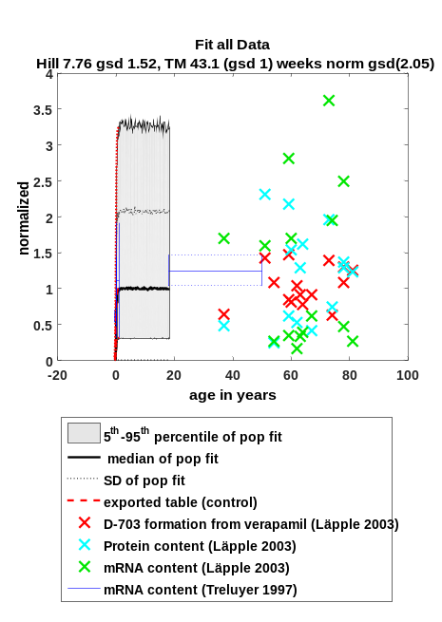 | 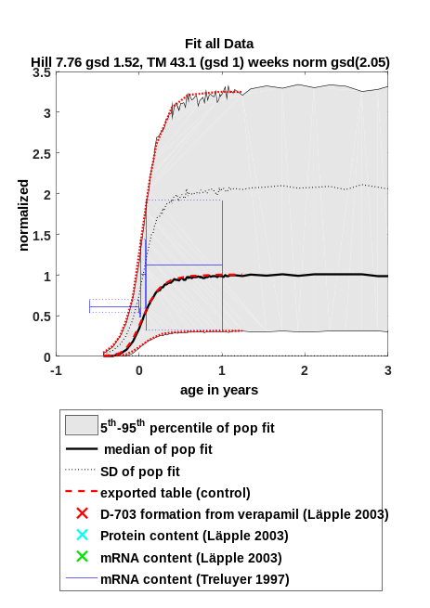
Comment:
For the intestine, the geometric standard deviation in activity observed in adults (‘GeoSD adult’) has been separately fitted and implemented with a GeoSD of 2.903

Fit function
Fit Result:
n = 7.758
A_{0.5} = 43.084

GeoSD n = 1.522
GeoSD A_{0.5} = 1.000
GeoSD adult = 2.054

A = PMA^{n}/(A_{0.5} ^{n} + PMA^{n})

With:
PMA = Post-menstrual age in weeks
A = Activity at PMA
A_{0.5} = PMA at 50 % activity compared to adult
n = Hill coefficient
GeoSD = geometric standard deviation
GeoSD adult = geometric standard deviation in activity observed in adults

Description for PK-Sim®
Values for CYP2C8 ontogeny are based on information to age dependency of mRNA expression, protein content and D-703 formation from verapamil, derived from the papers as mentioned in table A.4.1.

PK-Sim® Table

Post menstrual age [year(s)] | Ontogeny for CYP2C8 | Standard Deviation
0.34 | 0.001 | 9.23
0.45 | 0.0087 | 4.92
0.54 | 0.035 | 3.23
0.61 | 0.089 | 2.62
0.69 | 0.2 | 2.15
0.77 | 0.36 | 2.12
0.9 | 0.66 | 2.06
0.98 | 0.79 | 2.06
1.05 | 0.87 | 2.03
1.17 | 0.93 | 2.05
1.36 | 0.98 | 2.06
1.74 | 1 | 2.05

CYP2C9 in liver

Original data
Reference | Used for fit
J Pharmacol Exp Ther. 2004 Mar;308(3):965-74. Epub 2003 Nov 21.; Developmental expression of human hepatic CYP2C9 and CYP2C19.; Koukouritaki SB, Manro JR, Marsh SA, Stevens JC, Rettie AE, McCarver DG, Hines RN.  Digital Object Identifyer (DOI): 10.1124/jpet.103.060137  → Figure 2 (protein content)  → Table 1 (Diclofenac 4-hydroxylation)  → Figure 5 | Yes  Yes  No
Pharmacogenetics. 1997 Dec;7(6):441-52.; Developmental expression of CYP2C and CYP2C-dependent activities in the human liver: in-vivo/in-vitro correlation and inducibility.; Treluyer JM, Gueret G, Cheron G, Sonnier M, Cresteil T.  Pubmed ID (PMID): 9429229 (DOI not available)  → Figure 3 (Tolbutamide hydroxylation)  → Figure 5 (mRNA expression) | Yes  Yes
Pharmacogenetics. 2003 Sep;13(9):565-75.; Differential expression and function of CYP2C isoforms in human intestine and liver.; Läpple F, von Richter O, Fromm MF, Richter T, Thon KP, Wisser H, Griese EU, Eichelbaum M, Kivistö KT.  Digital Object Identifyer (DOI): 10.1097/01.fpc.0000054122.14659.1e  Pubmed ID (PMID): 12972955 (DOI not functioning)  →Table 3 (mRNA expression)  →Table 5 (4’hydroxydiclofenac formation, protein content) | Yes  Yes

Fit results

Figure

Full range-plot Zoom-in, x-axis
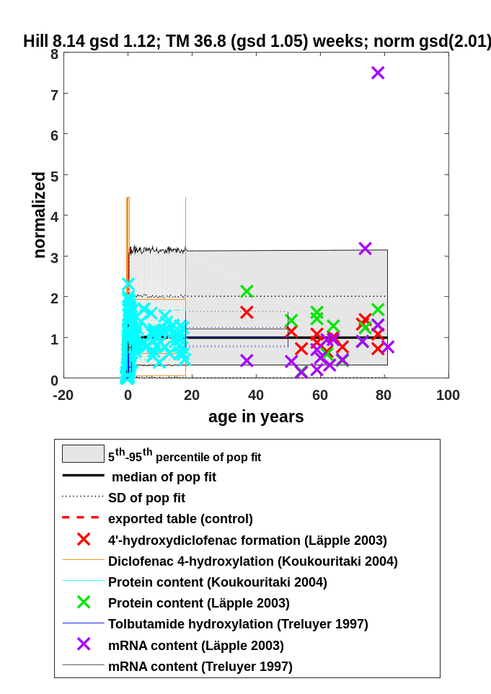 | 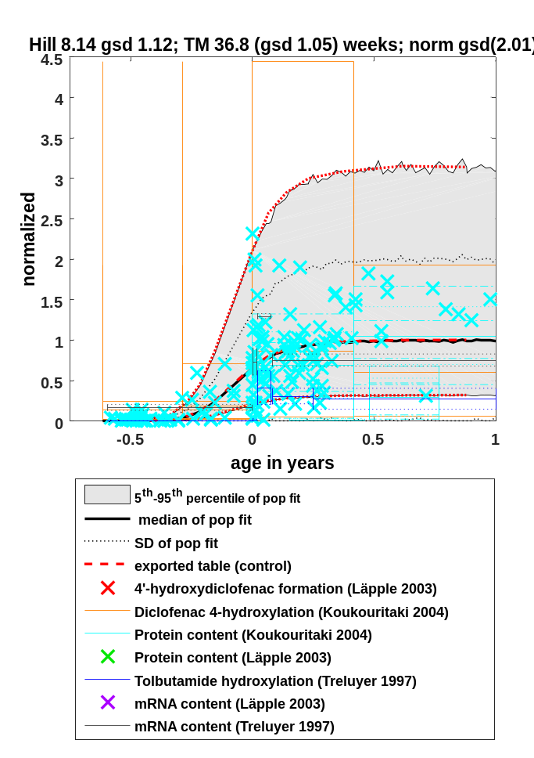

Comment:
For the intestine, the geometric standard deviation in activity observed in adults (‘GeoSD adult’) has been separately fitted and implemented with a GeoSD of 4.016

Fit function
Fit Result:
n = 8.135
A_{0.5} = 36.773

GeoSD n = 1.118
GeoSD A_{0.5} = 1.049
GeoSD adult = 2.006

A = PMA^{n}/(A_{0.5} ^{n} + PMA^{n})

With:
PMA = Post-menstrual age in weeks
A = Activity at PMA
A_{0.5} = PMA at 50 % activity compared to adult
n = Hill coefficient
GeoSD = geometric standard deviation
GeoSD adult = geometric standard deviation in activity observed in adults

Description for PK-Sim®
Values for CYP2C9 ontogeny are based on information to age dependency of mRNA expression, protein content, tolbutamide hydroxylation, and 4’hydroxydiclofenac formation, derived from the papers as mentioned in table A.5.1.

PK-Sim® Table

Post menstrual age [year(s)] | Ontogeny for CYP2C9 | Standard Deviation
0.3 | 0.00098 | 2.91
0.44 | 0.019 | 2.4
0.51 | 0.061 | 2.33
0.55 | 0.12 | 2.22
0.62 | 0.24 | 2.15
0.77 | 0.66 | 2.01
0.84 | 0.8 | 2.03
0.91 | 0.89 | 2.02
1 | 0.94 | 2.02
1.15 | 0.98 | 2.01
1.39 | 1 | 2.01

CYP2D6 in liver

Original data
Reference | Used for fit
Drug Metab Dispos. 2008 Aug;36(8):1587-93. doi: 10.1124/dmd.108.021873. Epub 2008 May 12.; Developmental changes in human liver CYP2D6 expression.; Stevens JC, Marsh SA, Zaya MJ, Regina KJ, Divakaran K, Le M, Hines RN.  Digital Object Identifyer (DOI): 10.1124/dmd.108.021873  → Figure 1A (Dextromethorphan-O-demethylation)  → Figure 1B (Dextromethorphan-O-demethylation)  → Figure 1C (Dextromethorphan-O-demethylation) | Yes  Yes  Yes
Eur J Biochem. 1991 Dec 5;202(2):583-8.; Expression of CYP2D6 in developing human liver.; Treluyer JM, Jacqz-Aigrain E, Alvarez F, Cresteil T.  Digital Object Identifyer (DOI): 10.1111/j.1432-1033.1991.tb16411.x  → Figure 1 (protein content)  → Figure 5 (Dextromethorphan-O-demethylation) | Yes  Yes

Fit results

Figure

Full range-plot Zoom-in, x-axis
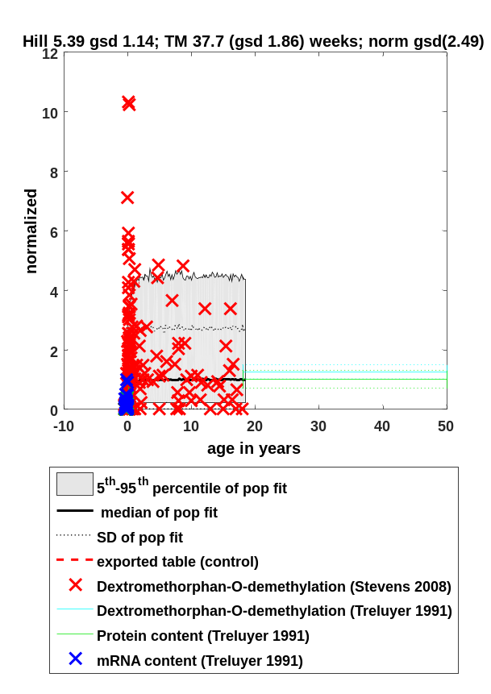 | 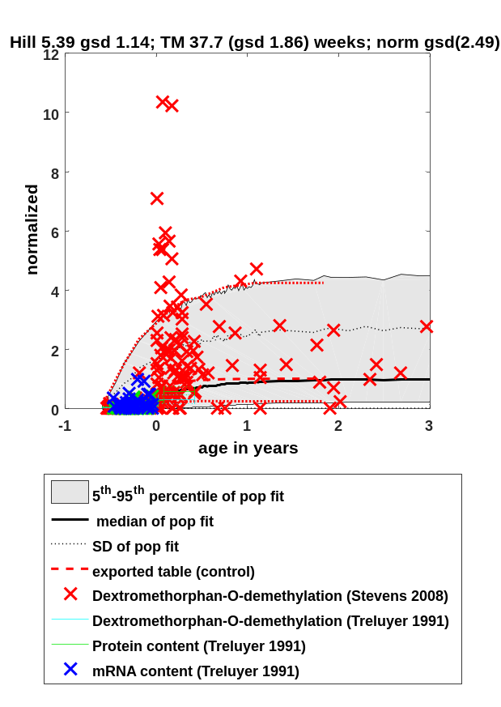

Fit function
Fit Result:
n = 5.391
A_{0.5} = 37.706

GeoSD n = 1.139
GeoSD A_{0.5} = 1.859
GeoSD adult = 2.488

A = PMA^{n}/(A_{0.5} ^{n} + PMA^{n})

With:
PMA = Post-menstrual age in weeks
A = Activity at PMA
A_{0.5} = PMA at 50 % activity compared to adult
n = Hill coefficient
GeoSD = geometric standard deviation
GeoSD adult = geometric standard deviation in activity observed in adults

Description for PK-Sim®
Values for CYP2D6 ontogeny are based on information to age dependency of protein content and dextromethorphan-O-demethylation activity, derived from the papers as mentioned in table A.6.1.

PK-Sim® Table

Post menstrual age [year(s)] | Ontogeny for CYP2D6 | Standard Deviation
0.2 | 0.001 | 27.88
0.32 | 0.012 | 14.29
0.41 | 0.046 | 8.25
0.49 | 0.1 | 5.76
0.58 | 0.23 | 4.13
0.77 | 0.58 | 2.65
0.86 | 0.71 | 2.46
0.96 | 0.82 | 2.38
1.09 | 0.9 | 2.35
1.26 | 0.95 | 2.3
1.52 | 0.98 | 2.38
1.86 | 0.99 | 2.41
2.61 | 1 | 2.41

CYP2E1 in liver

Original data
Reference | Used for fit
J Pharmacol Exp Ther. 2003 Oct;307(1):402-7.; Human hepatic CYP2E1 expression during development.; Johnsrud EK, Koukouritaki SB, Divakaran K, Brunengraber LL, Hines RN, McCarver DG.  Digital Object Identifyer (DOI): 10.1124/jpet.102.053124  Pubmed ID (PMID): 12972955 (DOI not functioning)  → Figure 2A (protein content)  → Figure 2B (protein content)  → Figure 3 (protein content) | Yes  Yes  Yes
Eur J Biochem. 1996 Jun 1;238(2):476-83.; Developmental expression of CYP2E1 in the human liver. Hypermethylation control of gene expression during the neonatal period.; Vieira I, Sonnier M, Cresteil T.  Digital Object Identifyer (DOI): 10.1111/j.1432-1033.1996.0476z.x  → Figure 1 (protein content)  → Figure 2 (Chlorzoxazone hydroxylation)  → Figure 3 (mRNA expression) | Yes  Yes  Yes

Fit results

Figure

Full range-plot Zoom-in, x-axis
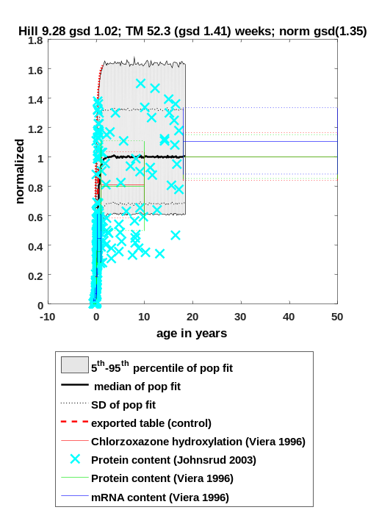 | 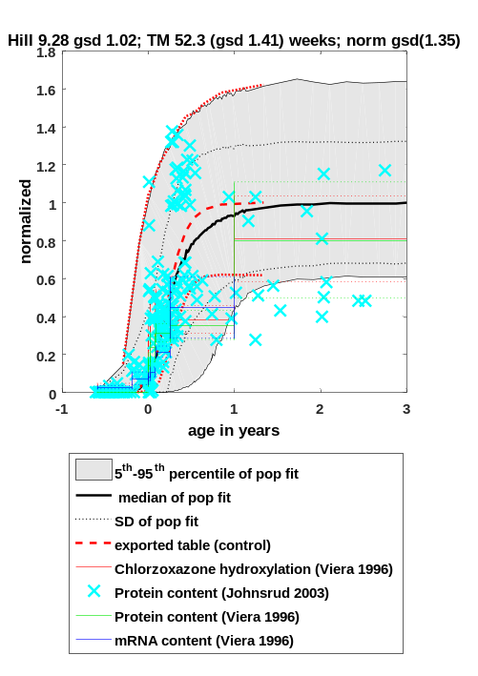

Fit function
Fit Result:
n = 9.277
A_{0.5} = 52.268

GeoSD n = 1.022
GeoSD A_{0.5} = 1.409
GeoSD adult = 1.350

A = PMA^{n}/(A_{0.5} ^{n} + PMA^{n})

With:
PMA = Post-menstrual age in weeks
A = Activity at PMA
A_{0.5} = PMA at 50 % activity compared to adult
n = Hill coefficient
GeoSD = geometric standard deviation
GeoSD adult = geometric standard deviation in activity observed in adults

Description for PK-Sim®
Values for CYP2E1 ontogeny are based on information to age dependency of mRNA expression, protein content and chlorzoxazone hydroxylation activity, derived from the papers as mentioned in table A.7.1.

PK-Sim® Table

Post menstrual age [year(s)] | Ontogeny for CYP2E1 | Standard Deviation
0.48 | 0.00099 | 21.07
0.66 | 0.021 | 9.07
0.77 | 0.077 | 4.85
0.82 | 0.13 | 3.67
0.9 | 0.26 | 2.51
1.05 | 0.6 | 1.63
1.12 | 0.73 | 1.47
1.21 | 0.85 | 1.39
1.3 | 0.92 | 1.33
1.43 | 0.96 | 1.32
1.62 | 0.99 | 1.33
2.12 | 1 | 1.34

CYP3A4 in liver

Original data
Reference | Used for fit
Eur J Biochem. 1997 Jul 15;247(2):625-34.; Expression of CYP3A in the human liver--evidence that the shift between CYP3A7 and CYP3A4 occurs immediately after birth.; Lacroix D, Sonnier M, Moncion A, Cheron G, Cresteil T.  Digital Object Identifyer (DOI): 10.1111/j.1432-1033.1997.00625.x  → Figure 3 (mRNA expression)  → Figure 4A-B (Testosterone 6 beta hydroxylation) | Yes  Yes
Drug Metab Dispos. 2003 Mar;31(3):275-81.; Oxidative metabolism of amprenavir in the human liver. Effect of the CYP3A maturation.; Tréluyer JM, Bowers G, Cazali N, Sonnier M, Rey E, Pons G, Cresteil T.  Digital Object Identifyer (DOI): 10.1124/dmd.31.3.275  → Table 5 (Amprenavir M2, M3 and M5 and formation) | Yes
J Pharmacol Exp Ther. 2003 Nov;307(2):573-82. Epub 2003 Sep 15.; Developmental expression of the major human hepatic CYP3A enzymes.; Stevens JC, Hines RN, Gu C, Koukouritaki SB, Manro JR, Tandler PJ, Zaya MJ.  Digital Object Identifyer (DOI): 10.1124/jpet.103.054841  → Figure 8 (protein content) | Yes
Drug Metab Dispos. 2000 Apr;28(4):379-82.; Human cytochrome P450 maximal activities in pediatric versus adult liver.; Blanco JG1, Harrison PL, Evans WE, Relling MV.  PMID: 10725303 (DOI not available)  → Figure 2 (Midazolam 1' hydroxylation) | No
Pharmacogenetics. 1997 Dec;7(6):441-52.; Developmental expression of CYP2C and CYP2C-dependent activities in the human liver: in-vivo/in-vitro correlation and inducibility.; Treluyer JM, Gueret G, Cheron G, Sonnier M, Cresteil T.  Pubmed ID (PMID): 9429229 (DOI not available)  → Figure 4B (Diazepam hydroxylation) | No

Fit results

Figure

Full range-plot Zoom-in, x-axis
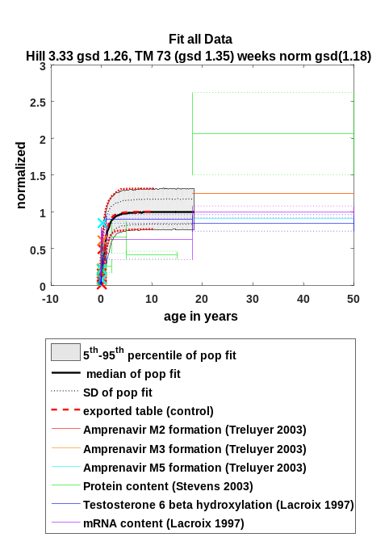 | 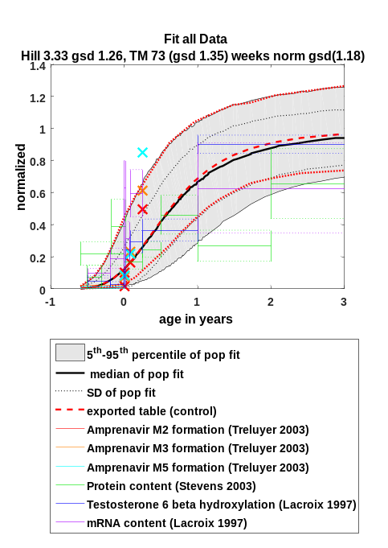
Comment:
The old PK-Sim® version was not fitted using the Hill equation but using spline functions allowing for the ‘overshoot’ of relative expression compared to adults. According to Edginton et al. 2006 an ontogeny factor of 1.3 was found for children from 1-3 y.
Reassessing in the light of additional data, the references quoted by Edginton et al 2006, such a high expression value for this age range could not be confirmed. The only CYP-mediated process found to yield an ontogeny factor of approx. 1.44 for children aged 3-12 months was reported by Treluyer et al. 1997 for the hydroxylation of diazepam (Fig. 4B). This metabolization, however, is not specific for CYP3A4 but is also mediated by CYP2C19 as reported by Riss et al. 2008 (Acta Neurol Scand. 118(2):69-86). Therefore, the age-dependency of this process was not considered for fitting CYP3A4 ontogeny in liver. Nevertheless, even if this dataset would have been considered, due to the different fit function the new ontogeny profile of CYP3A4 in liver would be significantly different than the old one.

Fit function
Fit Result:
n = 3.331
A_{0.5} = 73.019

GeoSD n = 1.255
GeoSD A_{0.5} = 1.345
GeoSD adult = 1.182

A = PMA^{n}/(A_{0.5} ^{n} + PMA^{n})

With:
PMA = Post-menstrual age in weeks
A = Activity at PMA
A_{0.5} = PMA at 50 % activity compared to adult
n = Hill coefficient
GeoSD = geometric standard deviation
GeoSD adult = geometric standard deviation in activity observed in adults

Description for PK-Sim®
Values for CYP3A4 ontogeny in liver are based on information to age dependency of mRNA content, testosterone 6 beta hydroxylation activity, protein content as well as amprenavir metabolite formation, derived from the papers as mentioned in table A.8.1.

PK-Sim® Table

Post menstrual age [year(s)] | Ontogeny for CYP3A4 | Standard Deviation
0.18 | 0.001 | 4.63
0.37 | 0.011 | 3.22
0.5 | 0.03 | 2.73
0.63 | 0.064 | 2.46
0.77 | 0.12 | 2.22
0.92 | 0.2 | 1.92
1.39 | 0.49 | 1.45
1.55 | 0.58 | 1.37
1.73 | 0.67 | 1.31
1.91 | 0.74 | 1.26
2.08 | 0.79 | 1.23
2.26 | 0.83 | 1.22
2.5 | 0.87 | 1.19
2.84 | 0.91 | 1.18
3.19 | 0.94 | 1.18
3.81 | 0.97 | 1.18
4.69 | 0.98 | 1.19
6.48 | 0.99 | 1.18
11.17 | 1 | 1.18

CYP3A5 in liver

Original data
Reference | Used for fit
J Pharmacol Exp Ther. 2003 Nov;307(2):573-82. Epub 2003 Sep 15.; Developmental expression of the major human hepatic CYP3A enzymes.; Stevens JC, Hines RN, Gu C, Koukouritaki SB, Manro JR, Tandler PJ, Zaya MJ.  Digital Object Identifyer (DOI): 10.1124/jpet.103.054841  → Figure 2 (protein content) | yes  →Although, no ontogeny visible for this protein.

Fit results

Figure

Full range-plot Zoom-in, x-axis
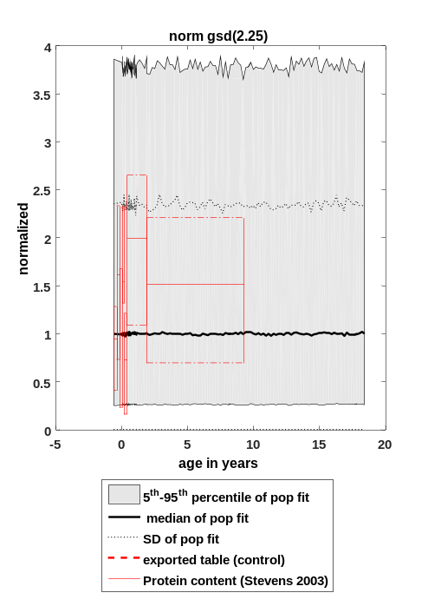 | 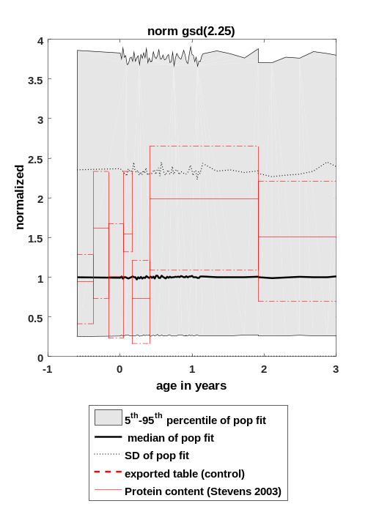
Comment:
Due to the variability of the data, no ontogeny fit for CYP3A5 is possible. The ontogeny function for this enzyme therefore is equal to one for all age groups.

Fit function

The ontogeny is equal to 1 for all ages. The geometric standard deviation in activity observed in adults is 2.246.

Description for PK-Sim®
CYP3A5 activity in liver is assumed to be at 100 % adult activity at all ages based on the data from Stevens et al. 2003 J Pharmacol Exp Ther 307(2):573-82.

PK-Sim® Table

Post menstrual age [year(s)] | Ontogeny for CYP3A5 | Standard Deviation
0 | 1 | 2.25
0.77 | 1 | 2.25

CYP3A7 in liver

Original data
Reference | Used for fit
Eur J Biochem. 1997 Jul 15;247(2):625-34.; Expression of CYP3A in the human liver--evidence that the shift between CYP3A7 and CYP3A4 occurs immediately after birth.; Lacroix D, Sonnier M, Moncion A, Cheron G, Cresteil T.  Digital Object Identifyer (DOI): 10.1111/j.1432-1033.1997.00625.x  → Figure 4A-B (Dehydroepiandrosterone hydroxylation) | Yes
J Pharmacol Exp Ther. 2003 Nov;307(2):573-82. Epub 2003 Sep 15.; Developmental expression of the major human hepatic CYP3A enzymes.; Stevens JC, Hines RN, Gu C, Koukouritaki SB, Manro JR, Tandler PJ, Zaya MJ.  Digital Object Identifyer (DOI): 10.1124/jpet.103.054841  → Figure 8 (protein content) | Yes

Fit results

Figure

Full range-plot Zoom-in, x-axis
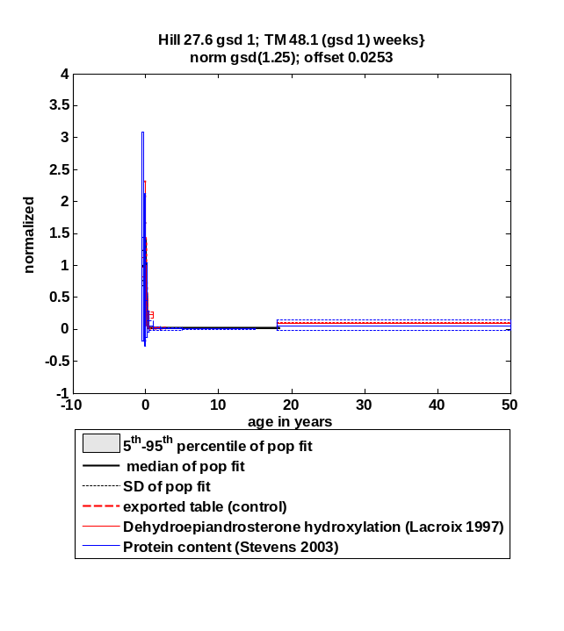 | 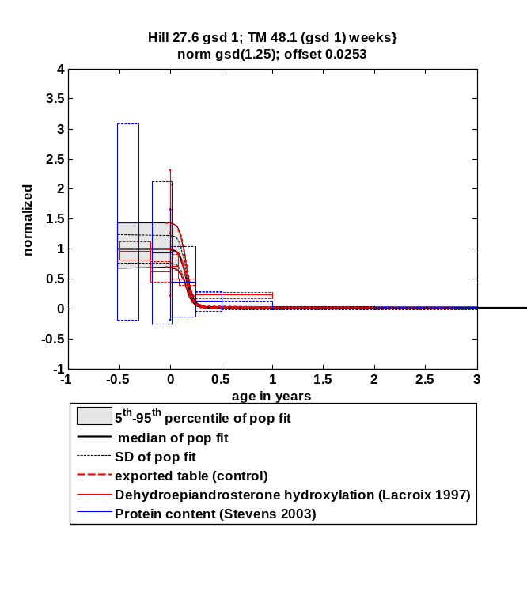

Fit function
Fit Result:
n = 27.615
A_{0.5} = 48.051

GeoSD A_{0.5} = 1
GeoSD n = 1
GeoSD adult = 1.254
Offset = 0.0253

A =1-PMA^{n}/(A_{0.5} ^{n} + PMA^{n}) + offset

With:
PMA = Post-menstrual age in weeks
A = Activity at PMA
A_{0.5} = PMA at 50 % activity compared to adult
n = Hill coefficient
GeoSD = geometric standard deviation
GeoSD adult = geometric standard deviation in activity observed in adults
Offset = activity in adults

Description for PK-Sim®
Values for CYP3A7 ontogeny are based on information to age dependency of protein content and dehydroepiandrosterone hydroxylation activity, derived from the papers as mentioned in table A.10.1.

PK-Sim® Table

Post menstrual age [year(s)] | Ontogeny for CYP3A7 | Standard Deviation
0.72 | 1 | 1.25
0.77 | 0.99 | 1.25
0.83 | 0.95 | 1.26
0.87 | 0.85 | 1.25
0.9 | 0.71 | 1.25
0.95 | 0.36 | 1.25
0.98 | 0.2 | 1.26
1.02 | 0.078 | 1.25
1.05 | 0.054 | 1.26
1.12 | 0.03 | 1.25
1.83 | 0.025 | 1.26
3.36 | 0.025 | 1.25
3.41 | 0.025 | 1.25
3.56 | 0.025 | 1.26

UGT enzymes in liver

UGT1A1 in liver

Original data
Reference | Used for fit
Dev Pharmacol Ther. 1989;13(2-4):70-7.; Development of human liver UDP-glucuronosyltransferases.; Burchell B, Coughtrie M, Jackson M, Harding D, Fournel-Gigleux S, Leakey J, Hume R.  Pubmed ID (PMID): 2515047 (DOI not available)  → Table 1 (Bilirubin glucuronidation)  → Table 2 (Bilirubin glucuronidation) | No  Yes
Drug Metab Dispos. 2011 May;39(5):912-9. doi: 10.1124/dmd.110.037192. Epub 2011 Jan 25.; The development of UDP-glucuronosyltransferases 1A1 and 1A6 in the pediatric liver.; Miyagi SJ, Collier AC.  Digital Object Identifyer (DOI): 10.1124/dmd.110.037192  → Figure 1A (Bilirubin glucuronidation) | No
Gut. 2002 Feb;50(2):259-65.; Developmental aspects of human hepatic drug glucuronidation in young children and adults.; Strassburg CP, Strassburg A, Kneip S, Barut A, Tukey RH, Rodeck B, Manns MP.  Digital Object Identifyer (DOI): 10.1136/gut.50.2.259  → Figure 2 (mRNA expression) | No
Biochem J. 1979 Dec 15;184(3):705-7.; Postnatal development of uridine diphosphate glucuronyltransferase activity towards bilirubin and 2-aminophenol in human liver.; Onishi S, Kawade N, Itoh S, Isobe K, Sugiyama S.  Digital Object Identifyer (DOI): 10.1042/bj1840705  → Figure 1 (Bilirubin glucuronidation) | Yes

Fit results

Figure

Full range-plot Zoom-in, x-axis
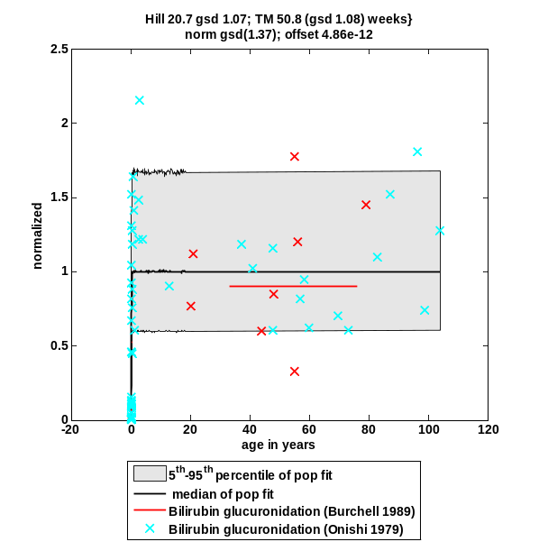 | 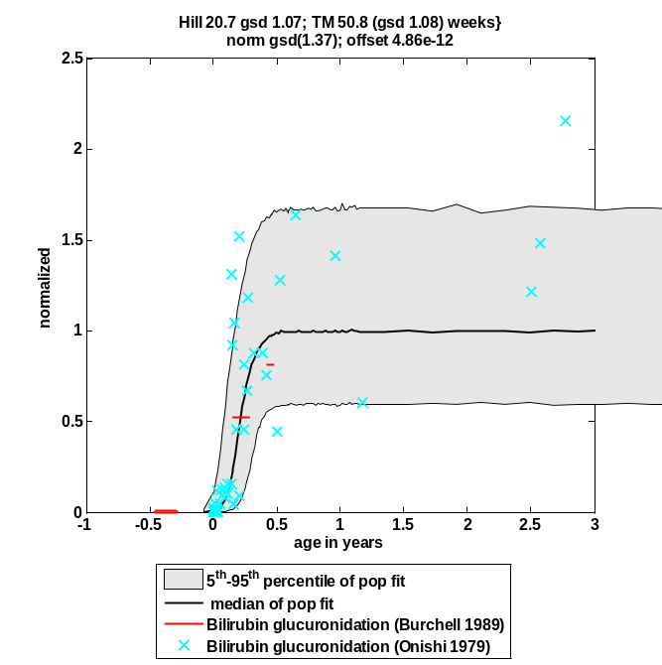

Fit function
Fit Result:
n = 20.670
A_{0.5} = 50.754

GeoSD n = 1.066
GeoSD A_{0.5} = 1.084
GeoSD adult = 1.367

A = PMA^{n}/(A_{0.5} ^{n} + PMA^{n})

With:
PMA = Post-menstrual age in weeks
A = Activity at PMA
A_{0.5} = PMA at 50 % activity compared to adult
n = Hill coefficient
GeoSD = geometric standard deviation
GeoSD adult = geometric standard deviation in activity observed in adults

Description for PK-Sim®
Values for UGT1A1 ontogeny are based on information to age dependency of mRNA expression, and bilirubin glucuronidation activity, derived from the papers as mentioned in table A.2.1.

PK-Sim® Table

Post menstrual age [year(s)] | Ontogeny for UGT1A1 | Standard Deviation
0.698271871 | 0.000979058 | 2.552011728
0.769230783 | 0.007233677 | 2.38158989
0.858116925 | 0.064657465 | 2.010226488
0.890073895 | 0.130265653 | 1.816496134
0.919260323 | 0.224505559 | 1.637136698
1.029093981 | 0.755379558 | 1.228398442
1.075121403 | 0.884206295 | 1.176906228
1.128819823 | 0.954406977 | 1.152582049
1.226630092 | 0.991511762 | 1.140699267
1.361833453 | 0.999002397 | 1.138464808

UGT1A4 in liver

Original data
Reference | Used for fit
Drug Metab Dispos. 2007 Sep;35(9):1587-92. Epub 2007 Jun 7.; Pediatric development of glucuronidation: the ontogeny of hepatic UGT1A4.; Miyagi SJ, Collier AC.  Digital Object Identifyer (DOI): 10.1124/dmd.107.015214  → Figure 3A (Trifluoperazine glucoronidation) | Yes  → although no ontogeny visible for this protein

Fit results

Figure

Full range-plot Zoom-in, x-axis
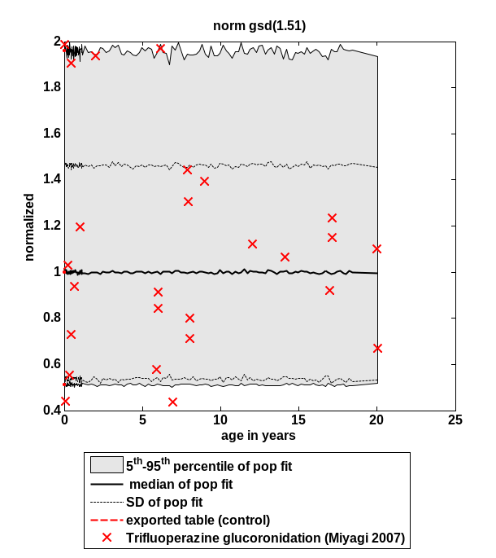 | 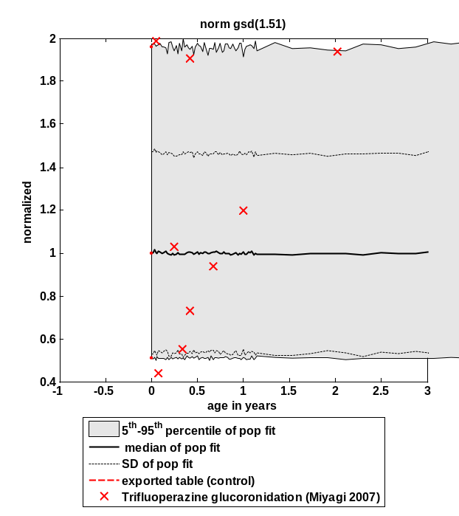
Comment:
Due to the variability of the data, no ontogeny fit using the Hill equation for UGT1A4 is possible. The ontogeny function for this enzyme therefore is equal to one for all age groups.
The curve shown in Miyagi et al. 2007 is a result of modeling hepatic UGT1A4 liver clearance assuming a constant rate of development. It therefore does not represent a true fit.

Fit function
The ontogeny is equal to 1 for all ages. The geometric standard deviation in activity observed in adults is 1.506.

Description for PK-Sim®
UGT1A4 activity in liver is assumed to be at 100 % adult activity at all ages based on the data from Miyagi 2007 Drug Metab Dispos 35(9):1587-1592.

PK-Sim® Table

Post menstrual age [year(s)] | Ontogeny for UGT1A4 | Standard Deviation
0 | 1 | 1.51
0.77 | 1 | 1.51

UGT1A6 in liver

Original data
Reference | Used for fit
Drug Metab Dispos. 2011 May;39(5):912-9. doi: 10.1124/dmd.110.037192. Epub 2011 Jan 25.; The development of UDP-glucuronosyltransferases 1A1 and 1A6 in the pediatric liver.; Miyagi SJ, Collier AC.  Digital Object Identifyer (DOI): 10.1124/dmd.110.037192  → Figure 2A (Serotonin glucuronidation) | Yes

Fit results

Figure

Full range-plot Zoom-in, x-axis
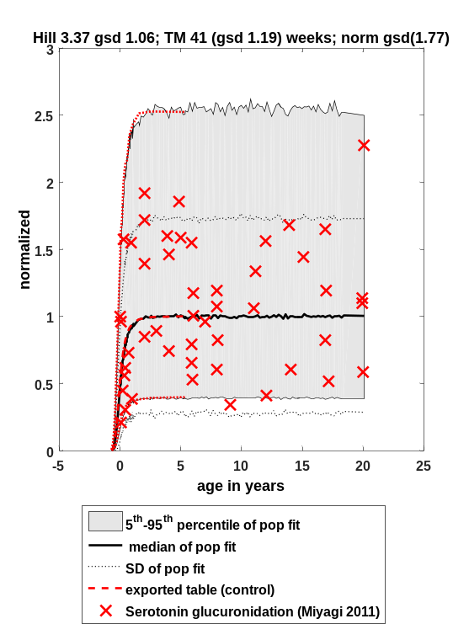 | 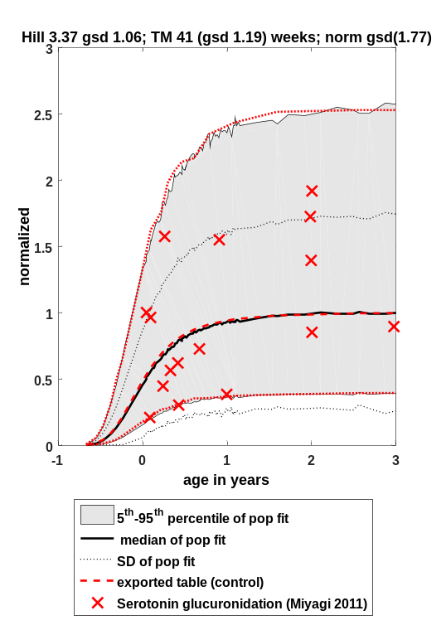
Comment:
The old PK-Sim fit was based on in vivo data of paracetamol glucuruonidation, i.e. paracetamol glucuronide to sulfate ratios (Edginton et al. 2006). The fit using in vitro serotonin glucuronidation data, however, shows a similar representation of UGT1A6 ontogeny.

Fit function
Fit Result:
n = 3.369
A_{0.5} = 41.030

GeoSD n = 1.064
GeoSD A_{0.5} = 1.192
GeoSD adult = 1.769

A = PMA^{n}/(A_{0.5} ^{n} + PMA^{n})

With:
PMA = Post-menstrual age in weeks
A = Activity at PMA
A_{0.5} = PMA at 50 % activity compared to adult
n = Hill coefficient
GeoSD = geometric standard deviation
GeoSD adult = geometric standard deviation in activity observed in adults

Description for PK-Sim®
Values for UGT1A6 ontogeny are based on information to age dependency of serotonin glucuronidation as reported by Miyagi 2011 Drug Metab Dispos 39(5): 912-919.

PK-Sim® Table

Post menstrual age [year(s)] | Ontogeny for UGT1A6 | Standard Deviation
0.1 | 0.001 | 2.49
0.22 | 0.013 | 2.36
0.3 | 0.038 | 2.23
0.39 | 0.088 | 2.14
0.45 | 0.13 | 2.16
0.53 | 0.21 | 1.99
0.77 | 0.48 | 1.85
0.87 | 0.58 | 1.87
0.99 | 0.69 | 1.77
1.07 | 0.74 | 1.82
1.15 | 0.78 | 1.81
1.24 | 0.82 | 1.79
1.38 | 0.87 | 1.74
1.57 | 0.91 | 1.78
1.86 | 0.95 | 1.77
2.37 | 0.98 | 1.78
3.34 | 0.99 | 1.76
6.13 | 1 | 1.76

UGT1A9 in liver

Original data
Reference | Used for fit
Gut. 2002 Feb;50(2):259-65.; Developmental aspects of human hepatic drug glucuronidation in young children and adults.; Strassburg CP, Strassburg A, Kneip S, Barut A, Tukey RH, Rodeck B, Manns MP.  Digital Object Identifyer (DOI): 10.1136/gut.50.2.259  → Figure 2 (mRNA expression) | Yes

Fit results

Figure

Full range-plot Zoom-in, x-axis
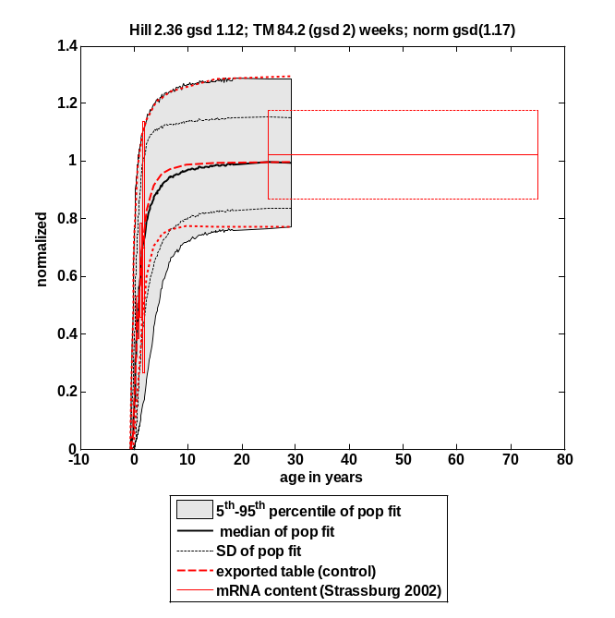 | 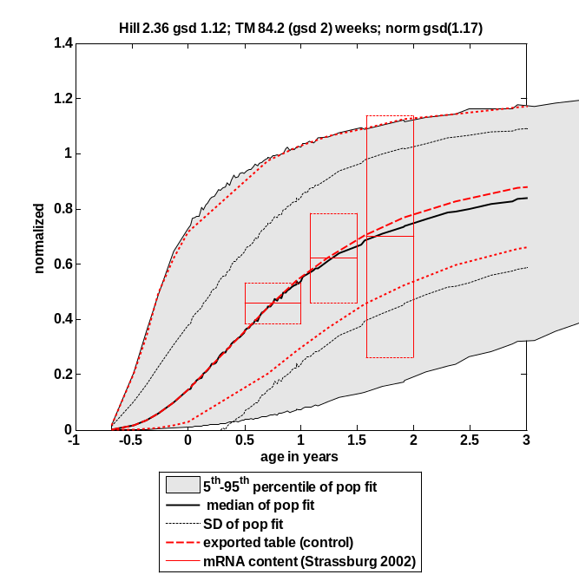

Fit function
Fit Result:
n = 2.362
A_{0.5} = 84.220

GeoSD n = 1.122
GeoSD A_{0.5} = 1.997
GeoSD adult = 1.169

A = PMA^{n}/(A_{0.5} ^{n} + PMA^{n})

With:
PMA = Post-menstrual age in weeks
A = Activity at PMA
A_{0.5} = PMA at 50 % activity compared to adult
n = Hill coefficient
GeoSD = geometric standard deviation
GeoSD adult = geometric standard deviation in activity observed in adults

Description for PK-Sim®
Values for UGT1A9 ontogeny are based on information to age dependency of mRNA expression as reported by Strassburg et al. 2002 Gut 50:259–265.

PK-Sim® Table

Post menstrual age [year(s)] | Ontogeny for UGT1A9 | Standard Deviation
0.09 | 0.00099 | 5.48
0.29 | 0.016 | 4.63
0.4 | 0.035 | 3.99
0.5 | 0.059 | 3.64
0.64 | 0.1 | 3.03
0.77 | 0.15 | 2.62
1.47 | 0.44 | 1.61
1.74 | 0.54 | 1.47
2.01 | 0.63 | 1.38
2.34 | 0.7 | 1.3
2.69 | 0.77 | 1.26
3.14 | 0.83 | 1.22
3.7 | 0.88 | 1.19
4.47 | 0.92 | 1.17
5.03 | 0.94 | 1.17
5.95 | 0.96 | 1.16
7.45 | 0.97 | 1.16
10.49 | 0.99 | 1.16
16.12 | 1 | 1.17

UGT2B4 in liver

Original data
Reference | Used for fit
Biochem J. 1979 Dec 15;184(3):705-7.; Postnatal development of uridine diphosphate glucuronyltransferase activity towards bilirubin and 2-aminophenol in human liver.; Onishi S, Kawade N, Itoh S, Isobe K, Sugiyama S.  Digital Object Identifyer (DOI): 10.1042/bj1840705  → Figure 2 (2-aminophenol glucuronidation) | Yes
Gut. 2002 Feb;50(2):259-65.; Developmental aspects of human hepatic drug glucuronidation in young children and adults.; Strassburg CP, Strassburg A, Kneip S, Barut A, Tukey RH, Rodeck B, Manns MP.  Digital Object Identifyer (DOI): 10.1136/gut.50.2.259  → Figure 2 (mRNA expression) | Yes

Fit results

Figure

Full range-plot Zoom-in, x-axis
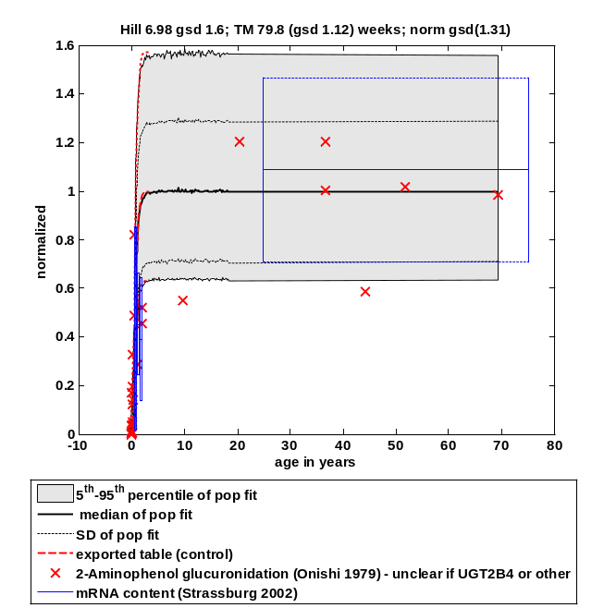 | 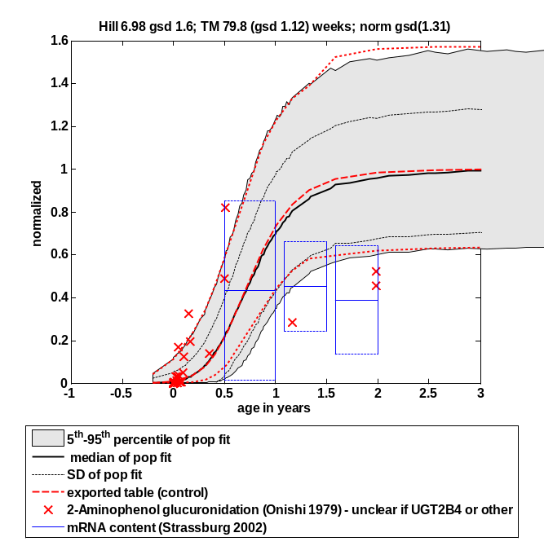

Fit function
Fit Result:
n = 6.983
A_{0.5} = 79.785

GeoSD n = 1.596
GeoSD A_{0.5} = 1.125
GeoSD adult = 1.314

A = PMA^{n}/(A_{0.5} ^{n} + PMA^{n})

With:
PMA = Post-menstrual age in weeks
A = Activity at PMA
A_{0.5} = PMA at 50 % activity compared to adult
n = Hill coefficient
GeoSD = geometric standard deviation
GeoSD adult = geometric standard deviation in activity observed in adults

Description for PK-Sim®
Values for UGT2B4 ontogeny are based on information to age dependency of 2-aminophenol Glucuronidation, and mRNA expression, derived from the papers as mentioned in table A.5.1.

PK-Sim® Table

Post menstrual age [year(s)] | Ontogeny for UGT2B7 | Standard Deviation
0.479999989 | 0.00099 | 17.12999916
0.660000026 | 0.0073 | 12.78999996
0.769999981 | 0.02 | 8.729999542
0.910000026 | 0.057 | 5.679999828
1.029999971 | 0.119999997 | 3.970000029
1.149999976 | 0.219999999 | 2.960000038
1.24000001 | 0.310000002 | 2.480000019
1.5 | 0.620000005 | 1.769999981
1.639999986 | 0.74000001 | 1.669999957
1.75999999 | 0.819999993 | 1.610000014
1.889999986 | 0.879999995 | 1.570000052
2.069999933 | 0.930000007 | 1.539999962
2.349999905 | 0.970000029 | 1.519999981
2.859999895 | 0.99000001 | 1.559999943
4.010000229 | 1 | 1.590000033

UGT2B7 in liver

Original data
Reference | Used for fit
Gut. 2002 Feb;50(2):259-65.; Developmental aspects of human hepatic drug glucuronidation in young children and adults.; Strassburg CP, Strassburg A, Kneip S, Barut A, Tukey RH, Rodeck B, Manns MP.  Digital Object Identifyer (DOI): 10.1136/gut.50.2.259  → Figure 2 (mRNA expression) | No
Drug Metab Dispos. 2006 Dec;34(12):2097-101.; Epub 2006 Sep 19.  Epirubicin glucuronidation and UGT2B7 developmental expression.; Zaya MJ1, Hines RN, Stevens JC.  Digital Object Identifyer (DOI): 10.1124/dmd.106.011387  → Figure 6 A (Epirubicin glucuronidation) | Yes
Eur J Clin Pharmacol. 1982;22(6):553-8.; Morphine glucuronidation in human fetal and adult liver.; Pacifici GM, Säwe J, Kager L, Rane A.  Digital Object Identifyer (DOI): 10.1007/BF00609630  → Figure 2 (Morphine glucuronidation) | Yes
Am J Dis Child. 1992 Aug;146(8):972-6.; The maturation of morphine clearance and metabolism.; McRorie TI, Lynn AM, Nespeca MK, Opheim KE, Slattery JT.  Digital Object Identifyer (DOI): 10.1001/archpedi.1992.02160200094036  → Figure 2 (Morphine glucuronide clearance) | Yes
Clin Pharmacokinet. 2006;45(10):1013-34.; Development and evaluation of a generic physiologically based pharmacokinetic model for children.; Edginton AN, Schmitt W, Willmann S.  Digital Object Identifyer (DOI): 10.2165/00003088-200645100-00005  →Table 3 (Lorazepam and morphine clearance) | Yes

Fit results

Figure

Full range-plot Zoom-in, x-axis
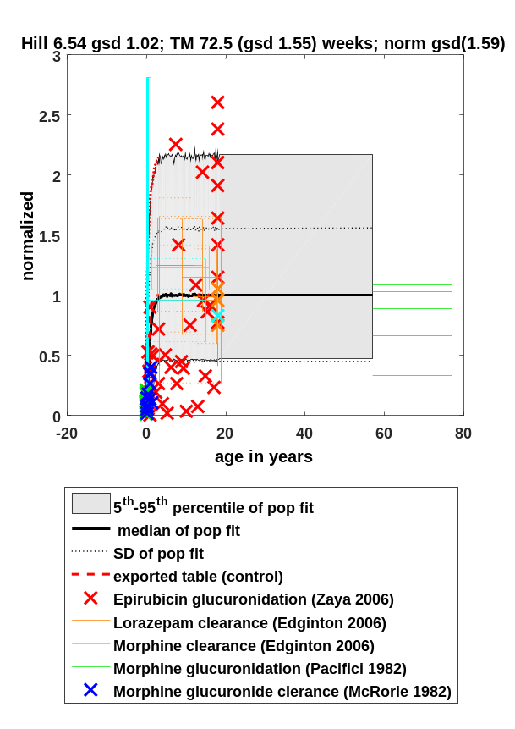 | 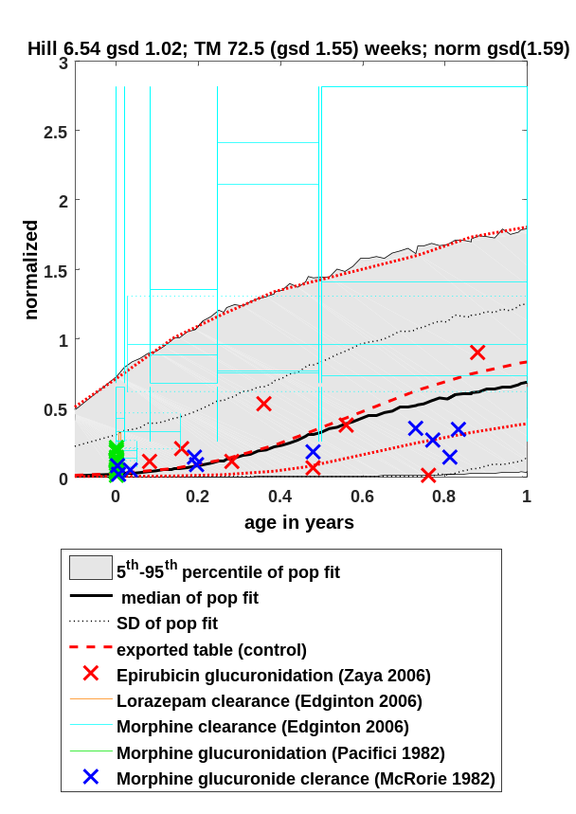

Fit function
Fit Result:
n = 6.543
A_{0.5} = 72.533

GeoSD n = 1.023
GeoSD A_{0.5} = 1.554
GeoSD adult = 1.595

A = PMA^{n}/(A_{0.5} ^{n} + PMA^{n})

With:
PMA = Post-menstrual age in weeks
A = Activity at PMA
A_{0.5} = PMA at 50 % activity compared to adult
n = Hill coefficient
GeoSD = geometric standard deviation
GeoSD adult = geometric standard deviation in activity observed in adults

Description for PK-Sim®
Values for UGT2B7 ontogeny are based on information to age dependency morphine glucuronidation activity, epirubicin glucuronidation activity, as well as in vivo morphine and lorazepam glucuronide clearance, derived from the papers as mentioned in table A.6.1.

PK-Sim® Table
Post menstrual age [year(s)] | Ontogeny for UGT2B7 | Standard Deviation
0.479999989 | 0.00099 | 17.12999916
0.660000026 | 0.0073 | 12.78999996
0.769999981 | 0.02 | 8.729999542
0.910000026 | 0.057 | 5.679999828
1.029999971 | 0.119999997 | 3.970000029
1.149999976 | 0.219999999 | 2.960000038
1.24000001 | 0.310000002 | 2.480000019
1.5 | 0.620000005 | 1.769999981
1.639999986 | 0.74000001 | 1.669999957
1.75999999 | 0.819999993 | 1.610000014
1.889999986 | 0.879999995 | 1.570000052
2.069999933 | 0.930000007 | 1.539999962
2.349999905 | 0.970000029 | 1.519999981
2.859999895 | 0.99000001 | 1.559999943
4.010000229 | 1 | 1.590000033

CYP Enzymes in the intestine

CYP3A4 in duodenum

Original data

Reference | Used for fit
Br J Clin Pharmacol. 2001 May;51(5):451-60.; Enterocytic CYP3A4 in a paediatric population: developmental changes and the effect of coeliac disease and cystic fibrosis.; Johnson TN, Tanner MS, Taylor CJ, Tucker GT.  Digital Object Identifyer (DOI): 10.1046/j.1365-2125.2001.01370.x  → Figure 2 (Protein content and Testosterone 6 beta hydroxylation) | Yes

Fit results

Figure

Full range-plot Zoom-in, x-axis
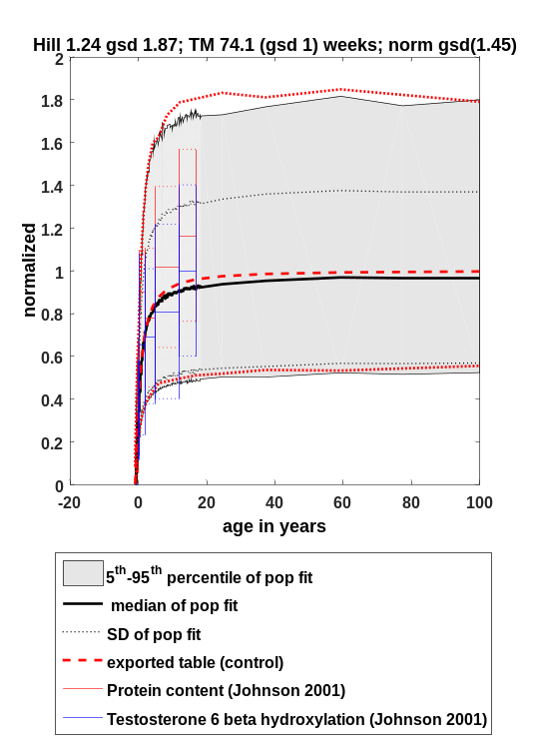 | 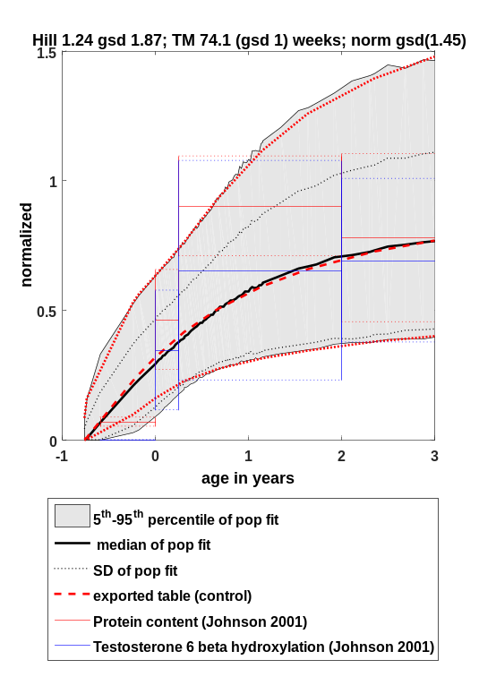

Fit function
Fit Result:
n = 1.237
A_{0.5} = 74.055

GeoSD n = 1.872
GeoSD A_{0.5} = 1.000
GeoSD adult = 1.451

A = PMA^{n}/(A_{0.5} ^{n} + PMA^{n})

With:
PMA = Post-menstrual age in weeks
A = Activity at PMA
A_{0.5} = PMA at 50 % activity compared to adult
n = Hill coefficient
GeoSD = geometric standard deviation
GeoSD adult = geometric standard deviation in activity observed in adults

Description for PK-Sim®
Values for CYP3A4 ontogeny in intestine are based on information to age dependency of protein content and testosterone 6 beta hydroxylation activity as described by Johnson et al. 2001 Br J Clin Pharmacol. 51(5):451-60.

PK-Sim® Table

Post menstrual age [year(s)] | Ontogeny for CYP3A4 | Standard Deviation
0.01 | 0.0011 | 13.99
0.03 | 0.0086 | 5.87
0.53 | 0.23 | 1.67
0.59 | 0.25 | 1.63
0.77 | 0.32 | 1.52
1.08 | 0.41 | 1.45
1.44 | 0.5 | 1.45
1.92 | 0.59 | 1.47
2.41 | 0.66 | 1.48
3.13 | 0.73 | 1.49
3.97 | 0.78 | 1.49
5.17 | 0.83 | 1.49
6.87 | 0.87 | 1.46
9.29 | 0.91 | 1.47
13.18 | 0.94 | 1.48
17.8 | 0.96 | 1.47
25.51 | 0.97 | 1.47
38.25 | 0.98 | 1.45
60.21 | 0.99 | 1.46
101.04 | 1 | 1.43

Other enzymes

Carboxylesterase 1 (CES1)
The CES-1 ontogeny for PK-Sim is based on the publication of Boberg et al. 2017. In the publication, an equation for the mean ontogeny is already given. Aim of the below described steps was the re-normalization of the ontogeny to reach a relative expression level of 1 for adults and the calculation of variability in dependence of age.

Original data

Reference | Used for fit
Boberg M, Vrana M, Mehrotra A, Pearce RE, Gaedigk A, Bhatt DK, Leeder JS, Prasad B. Age-Dependent Absolute Abundance of Hepatic Carboxylesterases (CES1 and CES2) by LC-MS/MS Proteomics: Application to PBPK Modeling of Oseltamivir In Vivo Pharmacokinetics in Infants. Drug Metab Dispos. 2017 Feb;45(2):216-223. doi: 10.1124/dmd.116.072652. Epub 2016 Nov 28. PMID: 27895113; PMCID: PMC5267516.  → Table 1 & 2 | See below

Ontogeny results

Data preparation
- Extraction of age group specific microsomal and cytosolic CES-1 concentrations from Table 2 (Boberg et al. 2017)
- Transformation of abundance values from pmol/mg total protein to pmol/mL of liver tissue using reported values of milligrams of microsomal and cytosolic proteins per gram of liver tissue (39.8 and 80.7 mg/ml, respectively; Boberg et al. 2017)
- Estimation of geometric means and geometric SDs from given arithmetic means and arithmetic SDs
  - geomean= mean^2/sqrt(SD^2+mean^2)
  - geosd = exp(sqrt(log(SD^2/mean^2+1)))
- Sum up values for microsomal and cytosolic protein concentrations to get total abundance for each age group
  - geomean_liver = sum(geomean_microsomal + geomean_cytosol)
  - geoSD_liver = exp(sqrt(((log(geoSD_microsomal)^2+log(geoSD_cytosol)^2))/2))

Variability fit
- Fit of an exponential decay model on the age-group dependent geoSDs
  - Model: exp(-k*Age)*(Onset-Offset)+Offset
  - Fit results:
    - K = 0.969
    - Onset = 2.095
    - Offset = 1.598
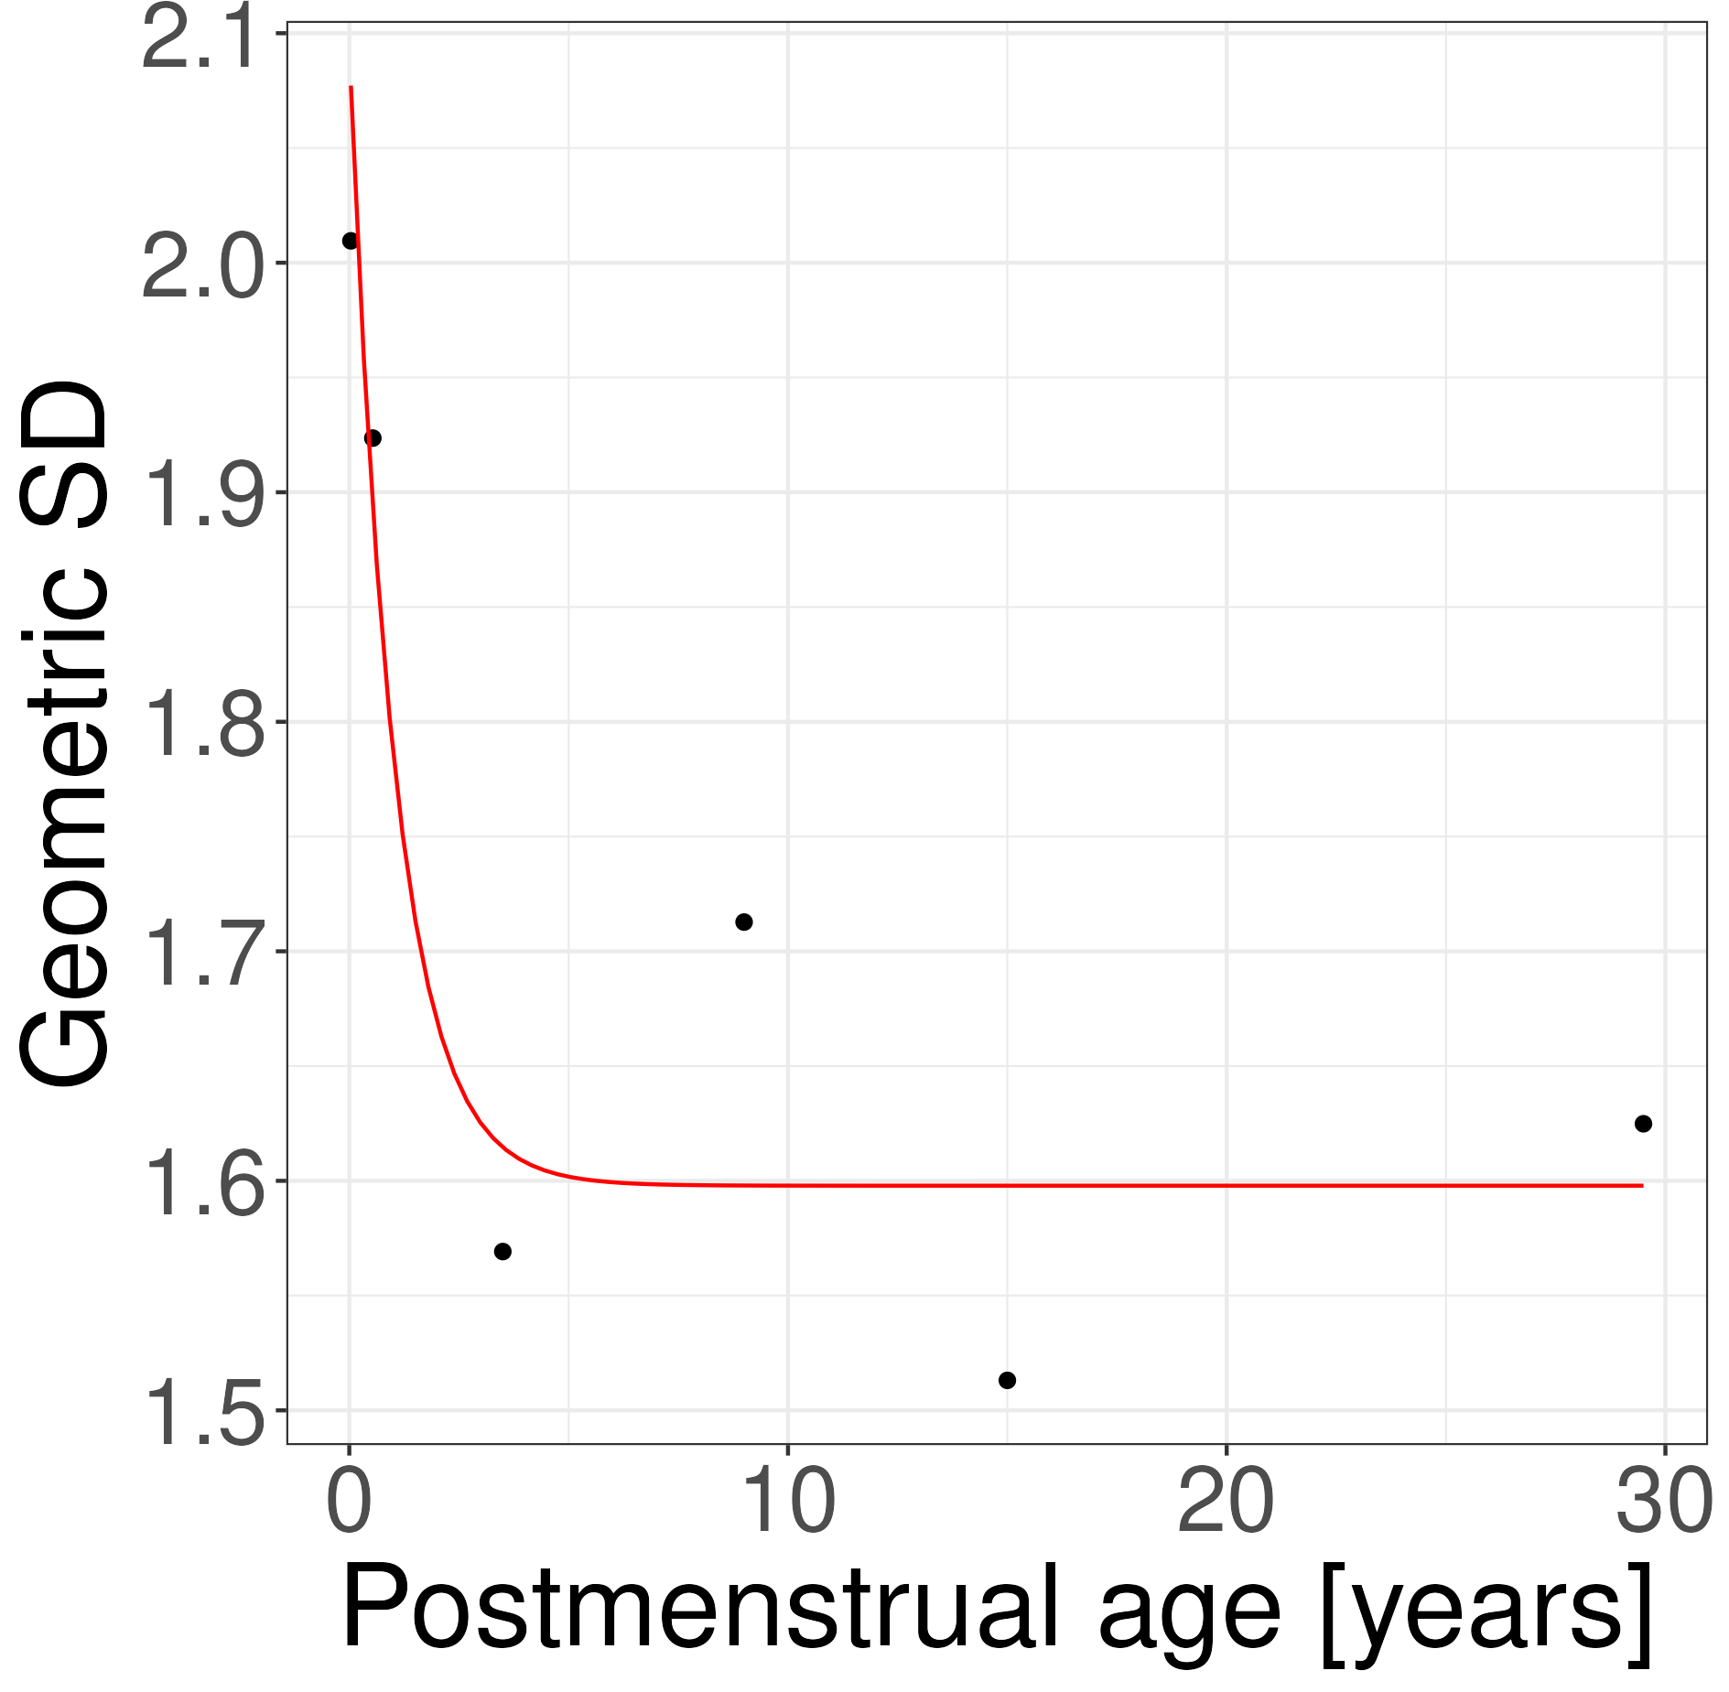

Re-normalization and ontogeny generation
- The geomean of the final ontogeny was calculated as follows:
  - Geomean of ontogeny factor calculated according to equation given in Boberg et al 2017 (Table 1)
  - 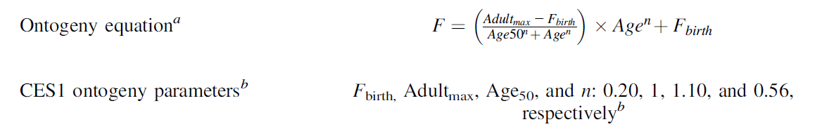
  - There is no information given in the publication regarding ontogeny in premature infants. Therefore, premature age ranges are not included in the final ontogeny.
  - Since the ontogeny never reaches 1 and individuals at 18 are only at ~0.86 the Adult_{max} value was set to 1.167231 (calculated by setting F to 1 and age to 18 and then resolving the equation for Adult_{max}) so that the ontogeny factor at age 18 is 1. All ages above were set to the same value as for 18year old individuals.
- The geoSD of the final ontogeny was calculated for each age step using the previously fitted equation.
- Final ontogeny:
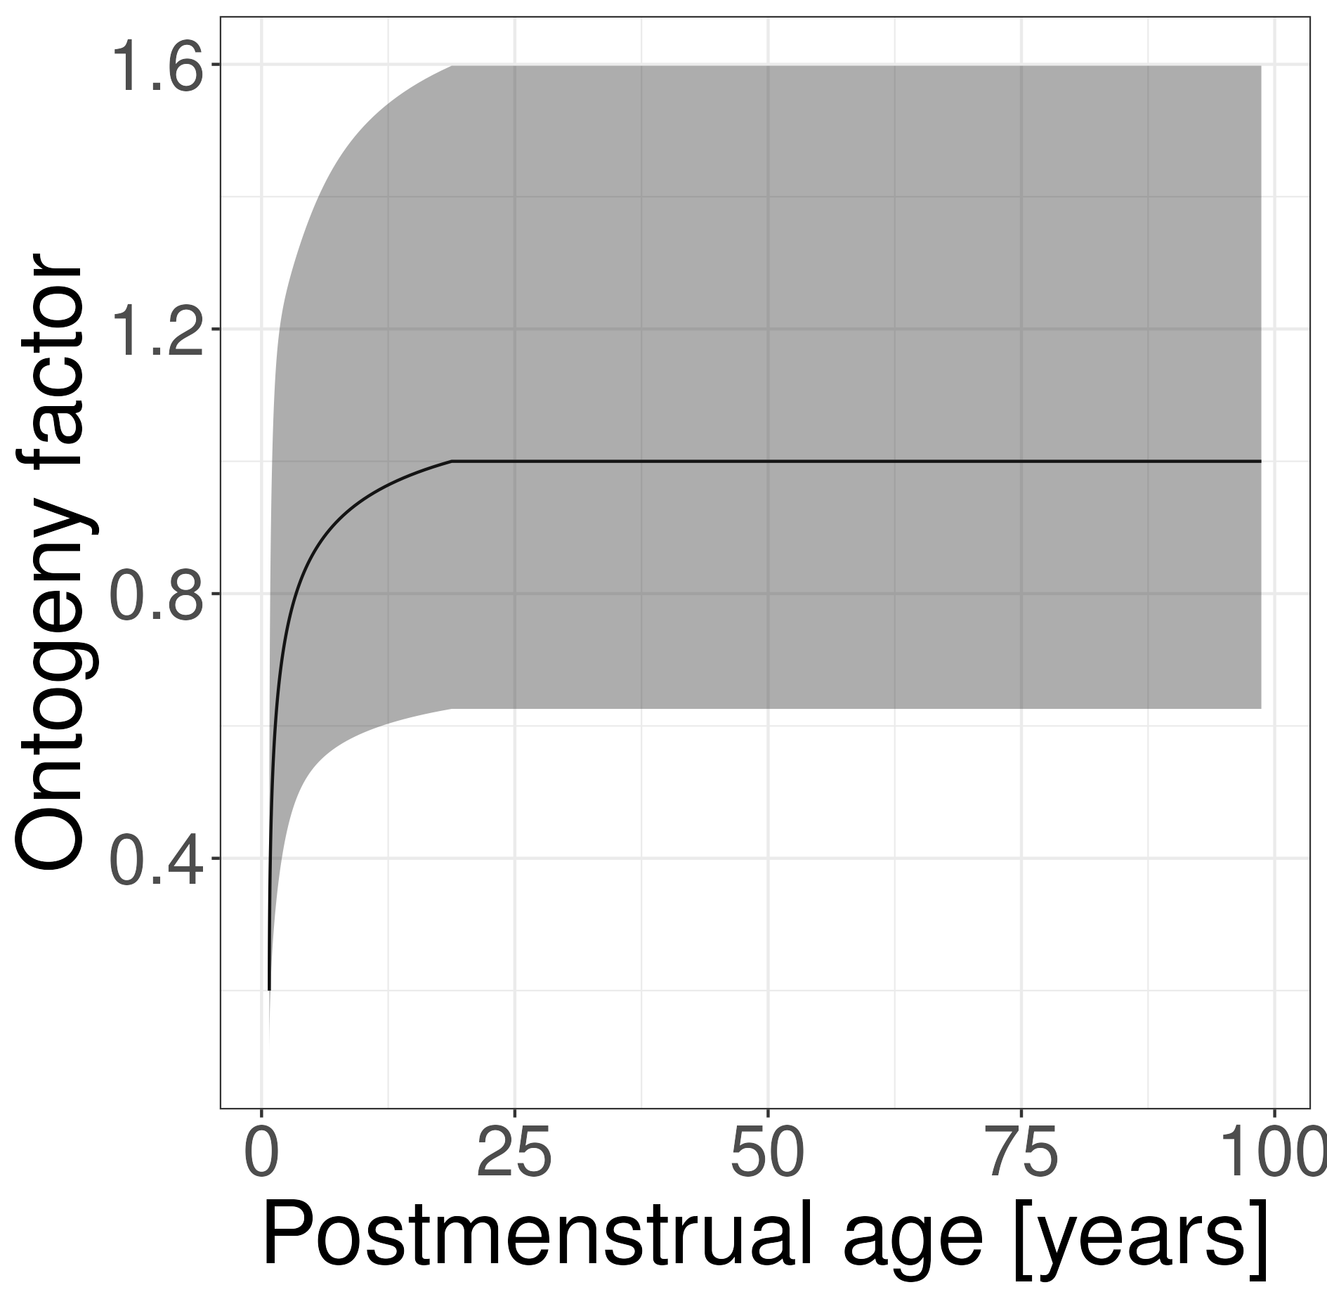

Description for PK-Sim®
Values for CES1 ontogeny are based on information to age dependency of protein content as described by Boberg et al. 2017.

PK-Sim® Table
Post menstrual age [year(s)] | Ontogeny for CES1 (Geometric Mean) | Geometric Standard Deviation
0.76659822 | 0.2 | 2.094629148
0.769336071 | 0.232541461 | 2.093313636
0.772073922 | 0.247221396 | 2.092001606
0.774811773 | 0.258530006 | 2.090693052
0.777549624 | 0.268041588 | 2.089387963
0.780287474 | 0.276382962 | 2.08808633
0.783025325 | 0.283881631 | 2.086788144
0.785763176 | 0.290734936 | 2.085493396
0.788501027 | 0.297072945 | 2.084202077
0.791238877 | 0.302986881 | 2.082914178
0.793976728 | 0.308543719 | 2.08162969
0.796714579 | 0.313794388 | 2.080348603
0.79945243 | 0.318778707 | 2.079070908
0.802190281 | 0.323528529 | 2.077796598
0.804928131 | 0.328069809 | 2.076525662
0.807665982 | 0.332424041 | 2.075258092
0.810403833 | 0.336609265 | 2.073993878
0.813141684 | 0.340640798 | 2.072733013
0.815879535 | 0.344531783 | 2.071475487
0.818617385 | 0.348293596 | 2.070221291
0.821355236 | 0.351936165 | 2.068970416
0.824093087 | 0.355468216 | 2.067722854
0.826830938 | 0.358897466 | 2.066478596
0.829568789 | 0.362230782 | 2.065237633
0.832306639 | 0.365474305 | 2.063999957
0.83504449 | 0.368633555 | 2.062765558
0.837782341 | 0.371713516 | 2.061534428
0.840520192 | 0.374718702 | 2.060306559
0.843258042 | 0.377653223 | 2.059081941
0.845995893 | 0.38052083 | 2.057860566
0.848733744 | 0.383324957 | 2.056642426
0.85152974 | 0.386126401 | 2.055401745
0.855884272 | 0.390371352 | 2.053476166
0.860462066 | 0.394688986 | 2.051460598
0.865274568 | 0.399079451 | 2.049351303
0.870333813 | 0.403542839 | 2.047144437
0.87565245 | 0.408079189 | 2.044836054
0.88124378 | 0.412688484 | 2.042422105
0.887121784 | 0.417370647 | 2.039898446
0.893301159 | 0.422125541 | 2.037260842
0.899797357 | 0.426952966 | 2.034504974
0.906626623 | 0.431852659 | 2.031626445
0.913806033 | 0.436824291 | 2.02862079
0.921353539 | 0.441867467 | 2.025483486
0.929288014 | 0.446981723 | 2.022209965
0.937629298 | 0.452166525 | 2.018795623
0.946398249 | 0.457421269 | 2.015235843
0.955616793 | 0.462745278 | 2.011526006
0.965307983 | 0.468137803 | 2.007661512
0.97549605 | 0.47359802 | 2.003637803
0.986206471 | 0.479125033 | 1.999450387
0.997466027 | 0.484717867 | 1.995094864
1.009302872 | 0.490375476 | 1.990566956
1.021746606 | 0.496096733 | 1.985862538
1.034828343 | 0.501880441 | 1.980977675
1.048580796 | 0.507725322 | 1.975908659
1.063038351 | 0.513630026 | 1.970652051
1.078237162 | 0.519593125 | 1.965204726
1.094215232 | 0.525613119 | 1.959563917
1.111012516 | 0.531688433 | 1.953727273
1.128671014 | 0.537817419 | 1.947692906
1.147234883 | 0.543998357 | 1.941459453
1.166750542 | 0.550229458 | 1.935026133
1.18726679 | 0.556508864 | 1.928392811
1.208834929 | 0.562834648 | 1.921560064
1.23150889 | 0.569204819 | 1.914529245
1.25534537 | 0.575617325 | 1.907302555
1.280403972 | 0.58207005 | 1.899883107
1.306747356 | 0.588560821 | 1.892275001
1.334441395 | 0.595087409 | 1.884483388
1.363555337 | 0.601647534 | 1.876514539
1.394161983 | 0.608238863 | 1.868375907
1.426337865 | 0.614859018 | 1.860076187
1.46016344 | 0.621505578 | 1.851625374
1.495723289 | 0.628176081 | 1.8430348
1.533106331 | 0.634868027 | 1.834317183
1.572406042 | 0.641578886 | 1.825486646
1.613720692 | 0.648306096 | 1.816558737
1.65715359 | 0.655047073 | 1.807550425
1.70281334 | 0.661799207 | 1.798480085
1.750814116 | 0.668559875 | 1.789367464
1.801275944 | 0.675326439 | 1.780233622
1.854325005 | 0.68209625 | 1.771100856
1.91009395 | 0.688866657 | 1.761992594
1.96872223 | 0.695635006 | 1.752933271
2.030356446 | 0.702398647 | 1.743948169
2.095150715 | 0.709154938 | 1.735063238
2.163267059 | 0.715901245 | 1.726304883
2.234875801 | 0.722634955 | 1.717699731
2.310156002 | 0.729353471 | 1.709274366
2.389295902 | 0.736054221 | 1.701055044
2.472493392 | 0.742734658 | 1.693067394
2.559956507 | 0.74939227 | 1.685336089
2.651903953 | 0.756024578 | 1.677884523
2.748565645 | 0.762629142 | 1.670734473
2.850183288 | 0.769203563 | 1.663905768
2.957010978 | 0.775745488 | 1.657415968
3.069315842 | 0.782252613 | 1.651280066
3.187378699 | 0.788722685 | 1.645510213
3.311494768 | 0.795153506 | 1.640115489
3.441974404 | 0.801542936 | 1.635101713
3.579143875 | 0.807888891 | 1.630471317
3.723346174 | 0.814189354 | 1.626223281
3.874941883 | 0.820442368 | 1.62235313
4.034310071 | 0.826646045 | 1.618853021
4.20184924 | 0.832798565 | 1.615711886
4.377978326 | 0.838898175 | 1.612915668
4.563137743 | 0.844943196 | 1.610447612
4.757790487 | 0.85093202 | 1.608288632
4.962423291 | 0.856863113 | 1.60641772
5.177547842 | 0.862735015 | 1.604812408
5.403702065 | 0.86854634 | 1.603449248
5.641451463 | 0.874295779 | 1.602304303
5.891390534 | 0.879982097 | 1.601353633
6.154144254 | 0.885604136 | 1.600573756
6.430369646 | 0.891160815 | 1.599942064
6.720757417 | 0.896651126 | 1.599437185
7.026033687 | 0.902074138 | 1.599039288
7.346961806 | 0.907428995 | 1.598730294
7.684344262 | 0.912714914 | 1.598494033
8.039024686 | 0.917931185 | 1.598316306
8.411889964 | 0.923077173 | 1.598184882
8.803872454 | 0.928152311 | 1.598089432
9.215952316 | 0.933156106 | 1.598021409
9.649159964 | 0.93808813 | 1.597973888
10.10457864 | 0.942948026 | 1.597941376
10.58334714 | 0.947735501 | 1.597919616
11.08666262 | 0.952450326 | 1.597905386
11.61578363 | 0.957092338 | 1.597896303
12.17203326 | 0.961661432 | 1.597890651
12.75680242 | 0.966157565 | 1.597887228
13.37155334 | 0.97058075 | 1.597885212
14.01782321 | 0.974931056 | 1.597884059
14.69722804 | 0.979208606 | 1.59788342
15.4114667 | 0.983413576 | 1.597883078
16.16232517 | 0.987546192 | 1.5978829
16.95168097 | 0.991606725 | 1.597882811
17.78150791 | 0.995595496 | 1.597882769
18.65388098 | 0.999512869 | 1.597882749
18.76659822 | 1 | 1.597882748
19.57098158 | 1 | 1.597882748
20.53510293 | 1 | 1.597882748
21.54865584 | 1 | 1.597882748
22.61417472 | 1 | 1.597882748
23.73432392 | 1 | 1.597882748
24.9119044 | 1 | 1.597882748
26.14986072 | 1 | 1.597882748
27.45128842 | 1 | 1.597882748
28.81944174 | 1 | 1.597882748
30.25774178 | 1 | 1.597882748
31.76978505 | 1 | 1.597882748
33.35935242 | 1 | 1.597882748
35.03041867 | 1 | 1.597882748
36.78716231 | 1 | 1.597882748
38.63397612 | 1 | 1.597882748
40.5754781 | 1 | 1.597882748
42.61652302 | 1 | 1.597882748
44.76221455 | 1 | 1.597882748
47.01791803 | 1 | 1.597882748
49.38927391 | 1 | 1.597882748
51.8822118 | 1 | 1.597882748
54.50296535 | 1 | 1.597882748
57.25808781 | 1 | 1.597882748
60.15446841 | 1 | 1.597882748
63.19934963 | 1 | 1.597882748
66.40034524 | 1 | 1.597882748
69.76545941 | 1 | 1.597882748
73.30310667 | 1 | 1.597882748
77.02213299 | 1 | 1.597882748
80.93183786 | 1 | 1.597882748
85.04199759 | 1 | 1.597882748
89.36288971 | 1 | 1.597882748
93.90531871 | 1 | 1.597882748
98.68064303 | 1 | 1.597882748

Transporter

P-glycoprotein 1 (P-gp)
The renal ontogeny of P-gp was published by Hunt et al. 2024. This ontogeny goes back to transporter expression measurements from human postmortem renal cortical tissue samples Cheung et al. 2019. The ontogeny of the renal P-gp transporter was applied to all other P-gp expressing organs, mainly, liver and intestine.

Original data

Reference | Used for fit
Hunt JP, Dubinsky S, McKnite AM, Cheung KWK, van Groen BD, Giacomini KM, de Wildt SN, Edginton AN, Watt KM. Maximum likelihood estimation of renal transporter ontogeny profiles for pediatric PBPK modeling. CPT Pharmacometrics Syst Pharmacol. 2024 Apr;13(4):576-588. doi: 10.1002/psp4.13102. Epub 2024 Jan 10. PMID: 38156758; PMCID: PMC11015082.  Table S4. P-gp Ontogeny Profiles “Lognormally Distributed” | Published ontogeny values
Cheung KWK, van Groen BD, Spaans E, van Borselen MD, de Bruijn ACJM, Simons-Oosterhuis Y, Tibboel D, Samsom JN, Verdijk RM, Smeets B, Zhang L, Huang SM, Giacomini KM, de Wildt SN. A Comprehensive Analysis of Ontogeny of Renal Drug Transporters: mRNA Analyses, Quantitative Proteomics, and Localization. Clin Pharmacol Ther. 2019 Nov;106(5):1083-1092. doi: 10.1002/cpt.1516. Epub 2019 Jul 3. PMID: 31127606; PMCID: PMC6777991. | Data used in ontogeny function generation in Hunt et al. 2024

Ontogeny results

Figure
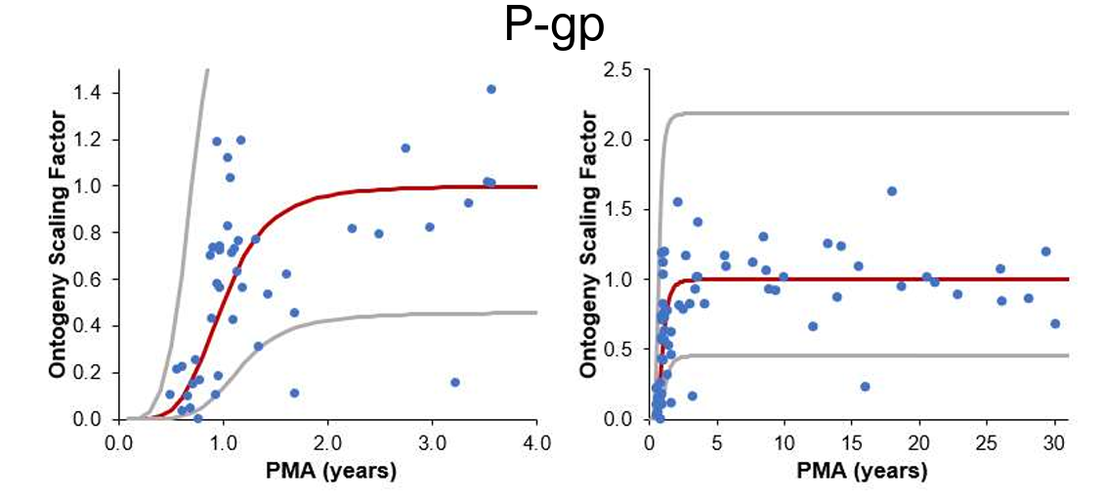
Figure adapted from Hunt et al. 2024, Figure S3

Description for PK-Sim®
Values for P-gp ontogeny are based on a published ontogeny (Hunt et al. 2024) which is based on transporter expression measurements (protein and mRNA) from human postmortem renal cortical tissue samples (Cheung et al. 2019).

PK-Sim® Table
Post menstrual age [year(s)] | Ontogeny for P-gp (Geometric Mean) | Geometric Standard Deviation
0.1 | 0 | 2.903
0.2 | 0.001 | 2.901
0.3 | 0.004 | 2.89
0.4 | 0.015 | 2.857
0.5 | 0.04 | 2.783
0.6 | 0.088 | 2.653
0.7 | 0.163 | 2.472
0.8 | 0.264 | 2.267
0.9 | 0.381 | 2.072
1 | 0.499 | 1.91
1.1 | 0.606 | 1.789
1.2 | 0.696 | 1.702
1.3 | 0.767 | 1.64
1.4 | 0.822 | 1.597
1.5 | 0.864 | 1.567
1.6 | 0.895 | 1.546
1.7 | 0.918 | 1.53
1.8 | 0.936 | 1.519
1.9 | 0.949 | 1.511
2 | 0.959 | 1.504
2.1 | 0.967 | 1.5
2.2 | 0.973 | 1.496
2.3 | 0.978 | 1.493
2.4 | 0.982 | 1.491
2.5 | 0.985 | 1.489
2.6 | 0.987 | 1.487
2.7 | 0.989 | 1.486
2.8 | 0.991 | 1.485
2.9 | 0.992 | 1.484
3 | 0.993 | 1.484
4 | 0.998 | 1.481
5 | 0.999 | 1.48
10 | 1 | 1.48
15 | 1 | 1.48
20 | 1 | 1.48
30 | 1 | 1.48
40 | 1 | 1.48
60 | 1 | 1.48
80 | 1 | 1.48
100 | 1 | 1.48

Plasma Proteins

Human Serum albumin (HSA)

Original data

Reference | Used for fit
AAPS PharmSci. 2002;4(1):E4.; Protein binding predictions in infants.; McNamara PJ1, Alcorn J.  Digital Object Identifyer (DOI): 10.1208/ps040104  → Figure 1 (serum protein concentrations) | Yes

Fit results

Figure

Full range-plot Zoom-in, x-axis
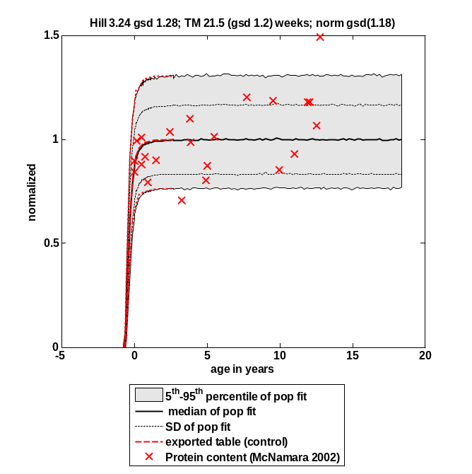 | 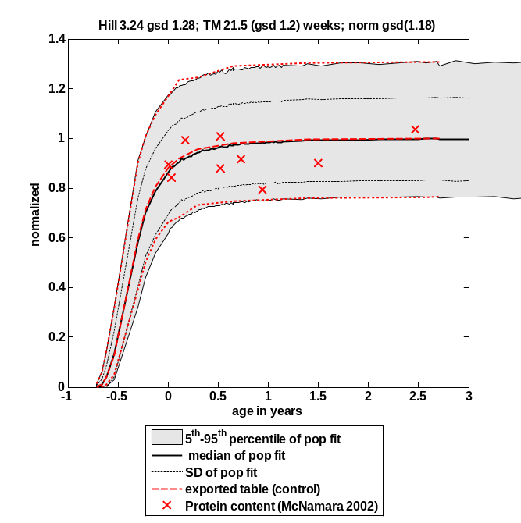

Fit function
Fit Result:
n = 3.240
A_{0.5} = 21.533

GeoSD n = 1.284
GeoSD A_{0.5} = 1.205
GeoSD adult = 1.177

A = PMA^{n}/(A_{0.5} ^{n} + PMA^{n})

With:
PMA = Post-menstrual age in weeks
A = Activity at PMA
A_{0.5} = PMA at 50 % activity compared to adult
n = Hill coefficient
GeoSD = geometric standard deviation
GeoSD adult = geometric standard deviation in activity observed in adults

Description for PK-Sim®
Values for Human Serum albumin ontogeny are based on information to age dependency of serum albumin concentrations, as reported by McNamara et al., AAPS PharmSci. 2002;4(1):E4.

PK-Sim® Table

Post menstrual age [year(s)] | Ontogeny for HSA | Standard Deviation
0.05 | 0.0011 | 4.46
0.1 | 0.011 | 2.8
0.16 | 0.04 | 2.2
0.23 | 0.13 | 1.74
0.46 | 0.59 | 1.29
0.55 | 0.71 | 1.24
0.64 | 0.81 | 1.2
0.77 | 0.88 | 1.19
0.88 | 0.92 | 1.2
1.06 | 0.96 | 1.17
1.42 | 0.98 | 1.18
2.17 | 1 | 1.18

Alpha-1-acid glycoprotein (AAG)

A new ontogeny for AAG has been implemented. This ontogeny is recently published at the PAGE 2018 Conference which is linked below:

Mayer et al., A novel approach to estimate ontogenies for PBPK applications – From literature data to simulations.

https://www.page-meeting.org/default.asp?abstract=8583

PK-Sim® Table

Post menstrual age [year(s)] | Ontogeny for AAG | Standard Deviation
0.766712298 | 0.254563711 | 1.829152038
0.770545289 | 0.288103739 | 1.881821245
0.77437828 | 0.320476631 | 1.840358216
0.785877253 | 0.404892648 | 1.715701843
0.797376226 | 0.47258055 | 1.628946923
0.805042209 | 0.510390851 | 1.588351585
0.816541182 | 0.558546687 | 1.54513096
0.831873146 | 0.610479462 | 1.508784277
0.847205111 | 0.652062602 | 1.486738469
0.889368013 | 0.732510638 | 1.459102868
0.946862879 | 0.798310922 | 1.447694197
1.035021675 | 0.855224822 | 1.443135263
1.169176363 | 0.900405864 | 1.441661523
1.387656856 | 0.935748949 | 1.441286708
1.721127082 | 0.96008023 | 1.441272349
3.032010039 | 0.987428363 | 1.441419782
13.60711841 | 1.002010167 | 1.441462514
30.76659822 | 1 | 1.440946066
90.45859001 | 0.986596986 | 1.443474188

